# Cover Page

**WEB CHAT**

DOCUMENTATION

Prepared by

**Amaan Al Mir**

# Table of Contents

Get Started

# Get Started

WebChat is designed for private groups where they can spend time together. A place where they can talk every day and hang out more often.

This web application is designed to be responsive and user-friendly to let individuals and groups communicate easily. The design has very simple layers of textures and functions. Unlike other online social media and communication services, this application wasn’t designed for commercial purposes, although business may also use it for their private purposes.

This documentation contains guides and reference materials to help you get started, integrate, optimize and troubleshoot your use of WebChat application.

(Discord, n.d.)

Contents

# User Guide

**USER**

**GUIDE**



## Requirements

### Devices

|  |  |  |
| --- | --- | --- |
| **Windows** | **Android** | **Apple** |
| Supported | Supported | Supported |

### Browsers

|  |  |  |  |  |  |
| --- | --- | --- | --- | --- | --- |
|  | **Chrome** | **Firefox** | **Microsoft Edge** | **Opera** | **Safari** |
|  | Supported | Supported | Supported | Supported | - |
|  | Supported | Supported | Supported | Supported | - |
|  | Supported | Supported | Supported | Supported | Supported |

**Note:** Internet Explorer is not supported.

### JavaScript

Most of the features and functions on this web application are rendered using JavaScript. Therefore, to run this site without any errors you must enable JavaScript on your browser.

(Otto, 2022)

(ASP.NET, n.d.)

(SQL Server, 2022)

(Web Development with ASP.NET MVC and Core, 2022)

## Site Map

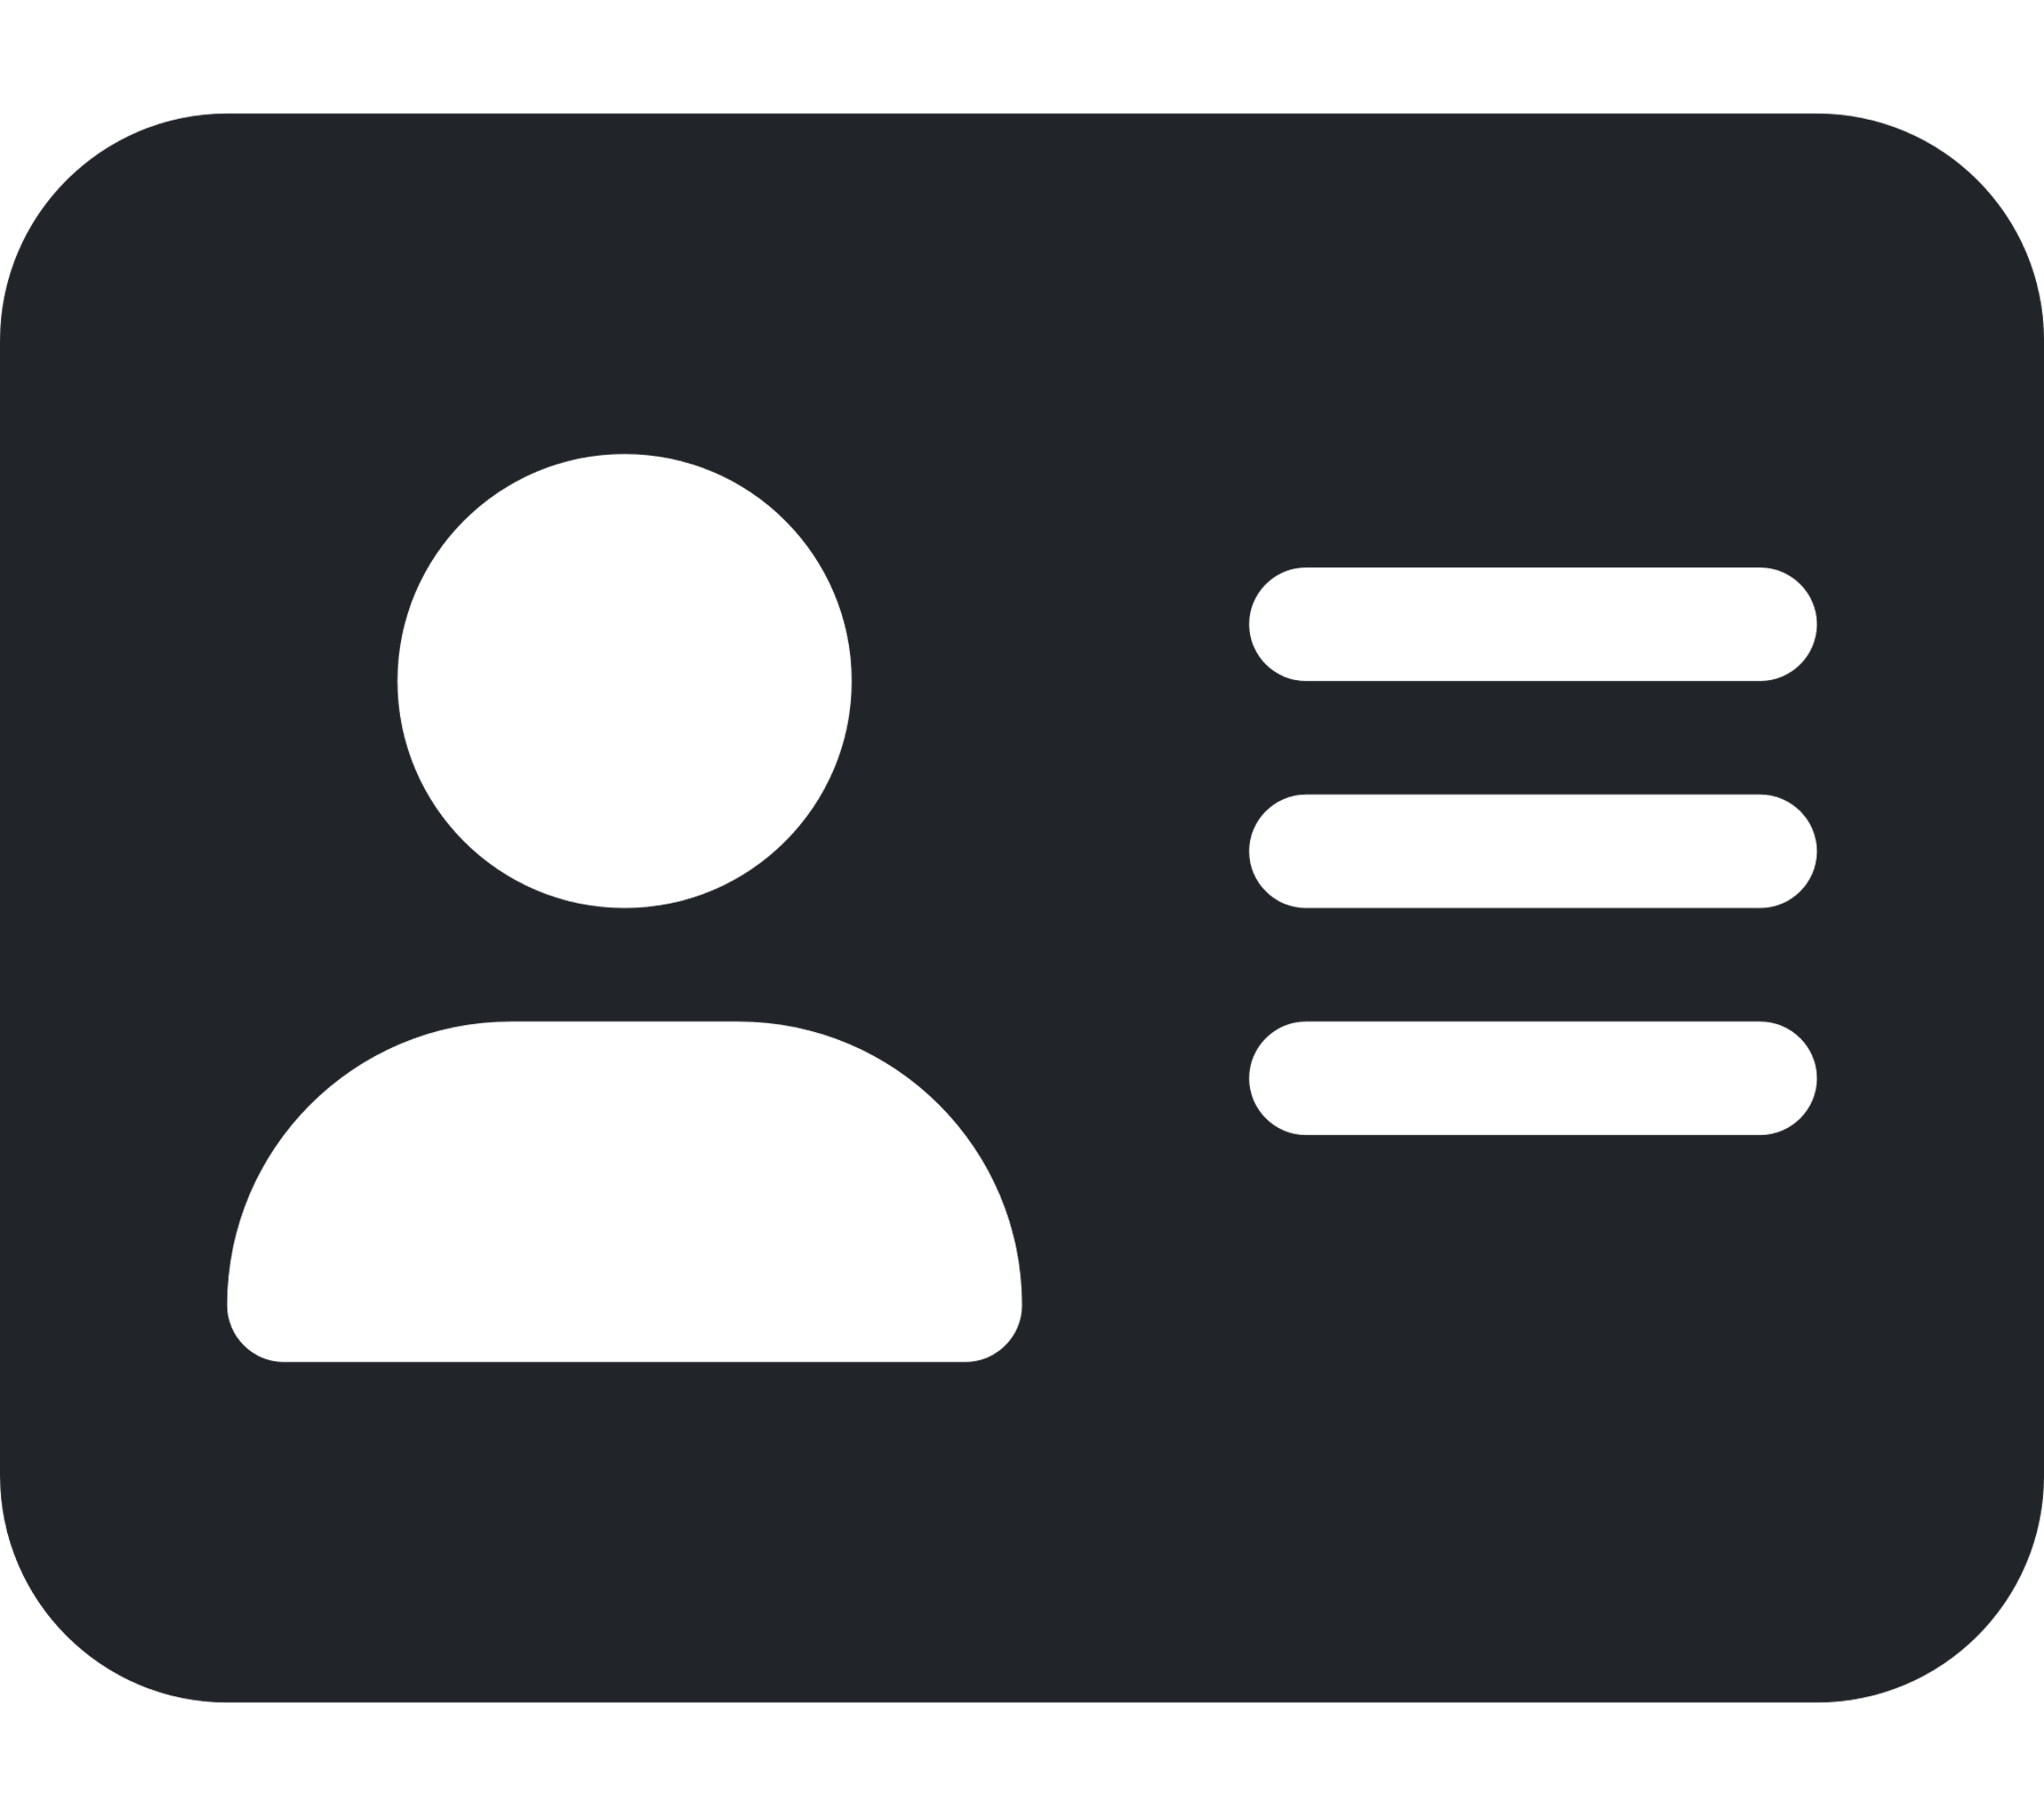

## Demonstration

### Login

There are two ways to signing in to the application.

1. Manual login - Using existing account credentials.

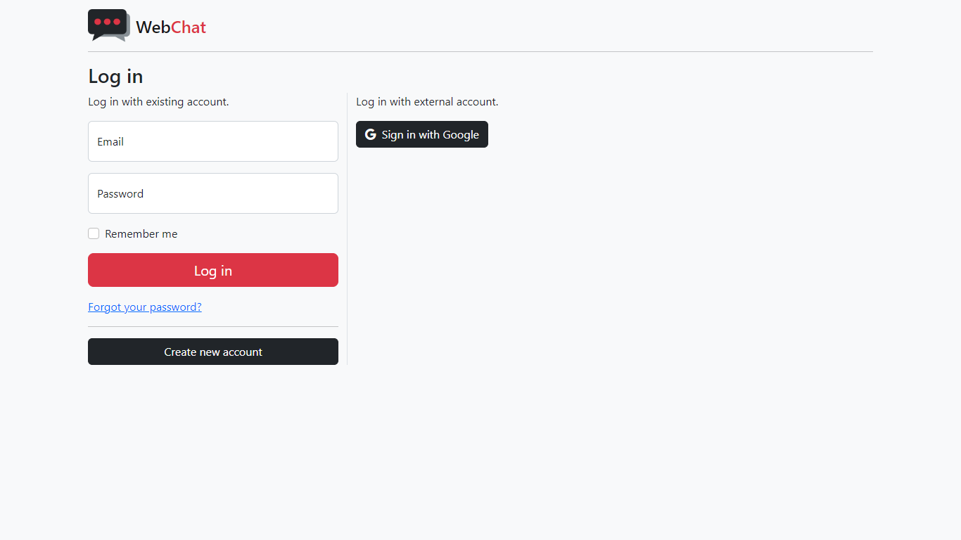

* Log in using the same email and password you used for registration.

1. Fast Login – Using an external account like Google.



* Clicking on this button will take you to Google sign in page.

If this is your first time using the application, using the external login method will take you to the registration page.

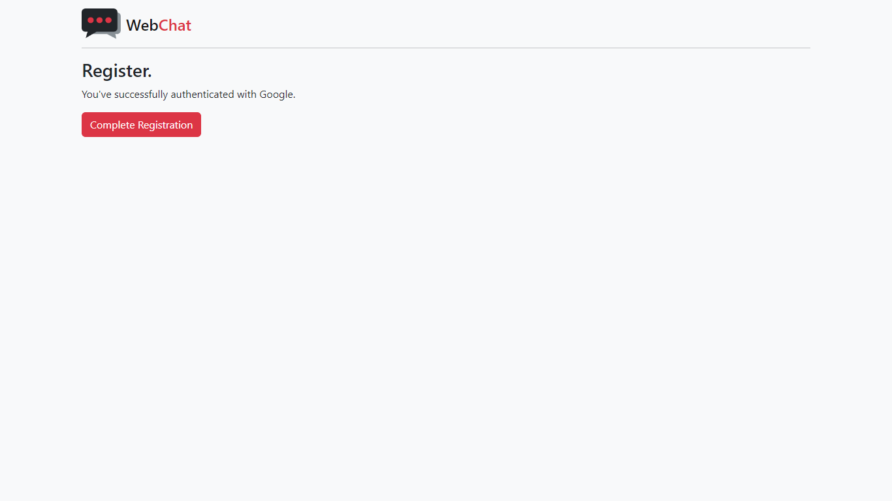

Simply click on “Complete Registration” to successfully connect your external account like Google with WebChat.

### Register

If you want to set up a new account on WebChat. Go to the registration page by clicking on the “Create new account” button from the login page.



This is the page you’ll land on to create a new account.

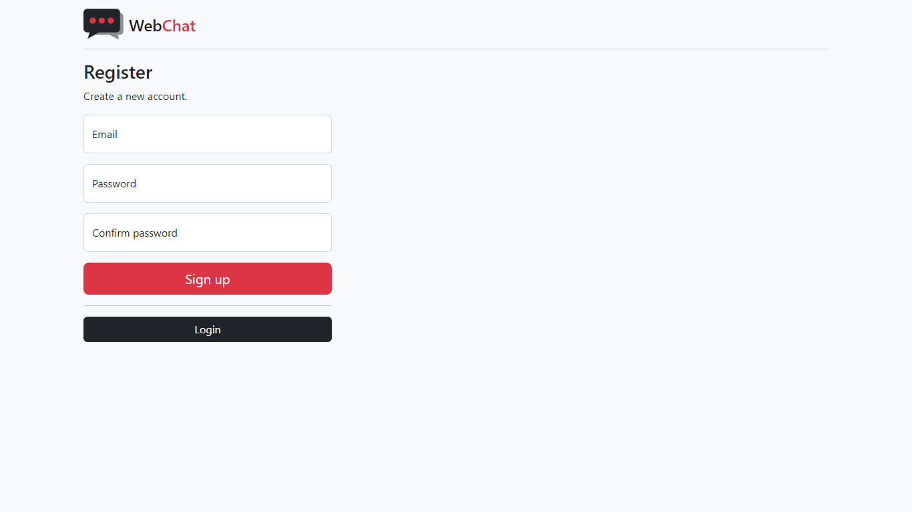

Fill in the required fields and click on “Sign up” to create a new account.

Once you have filled in proper and valid information, you’ll receive a verification link in the email you used to register.

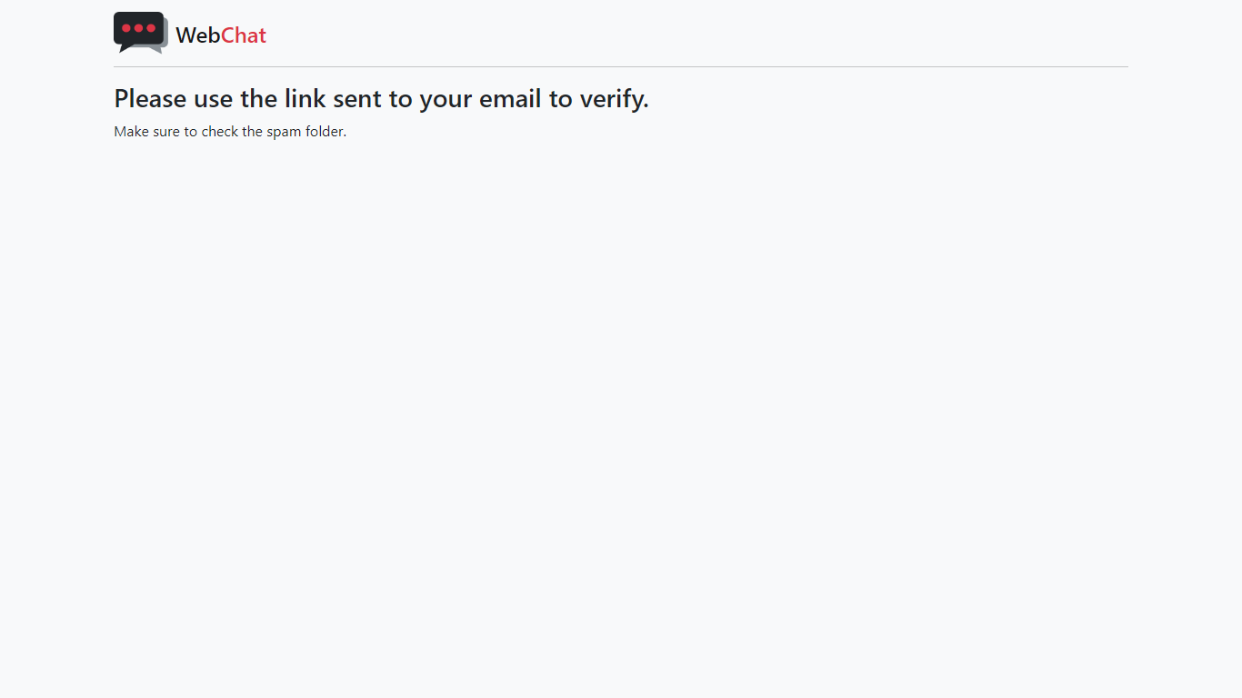

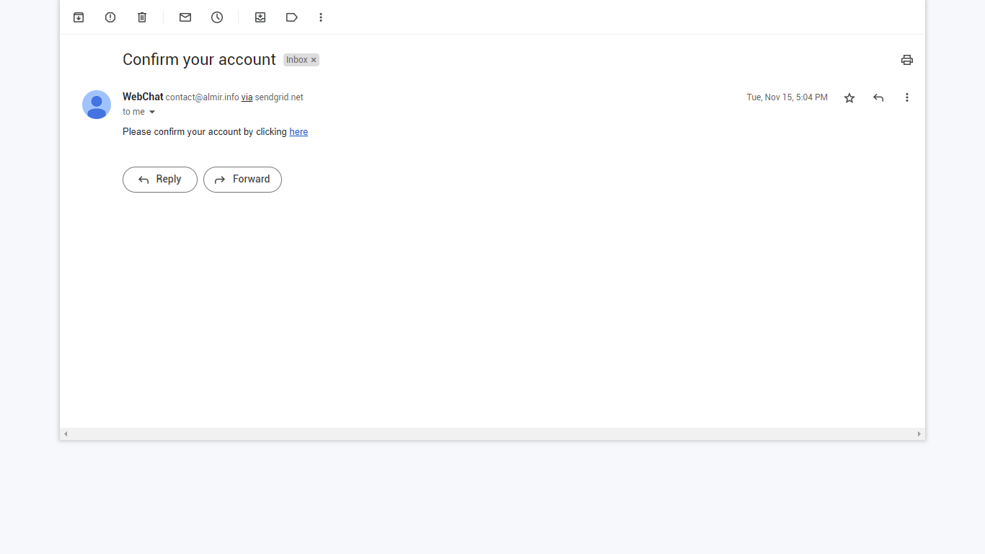

* Use the link to confirm your email.

If this process is successfully carried out, your email should be verified.

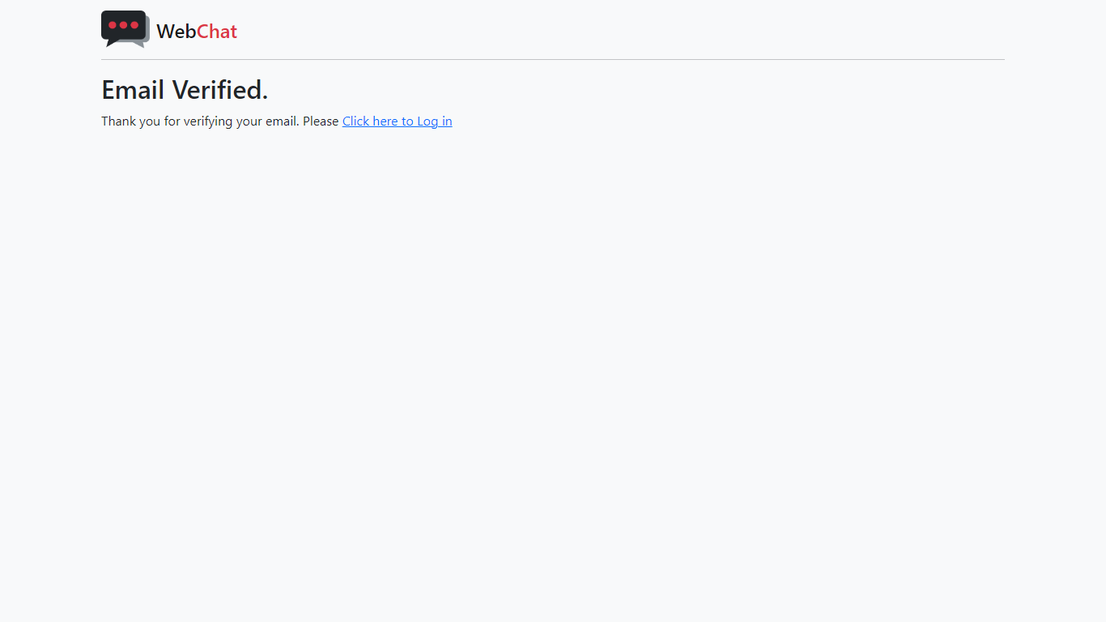

Clicking on the login link will take you back to the login page and you can login to the application using the same credentials you used to register.

You can navigate through the pages using the navbar which can be found on top of the page.

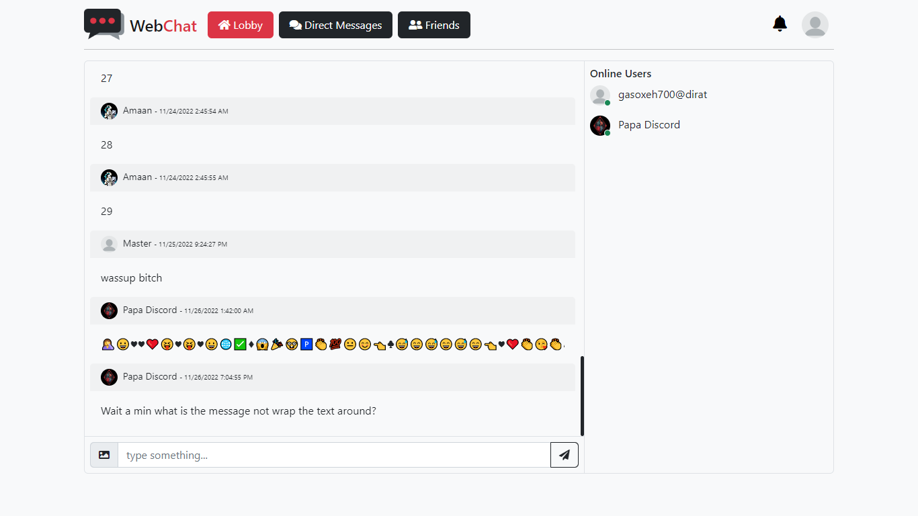

Click on your image on top-right corner to get the option to view and edit your profile or change your account settings.

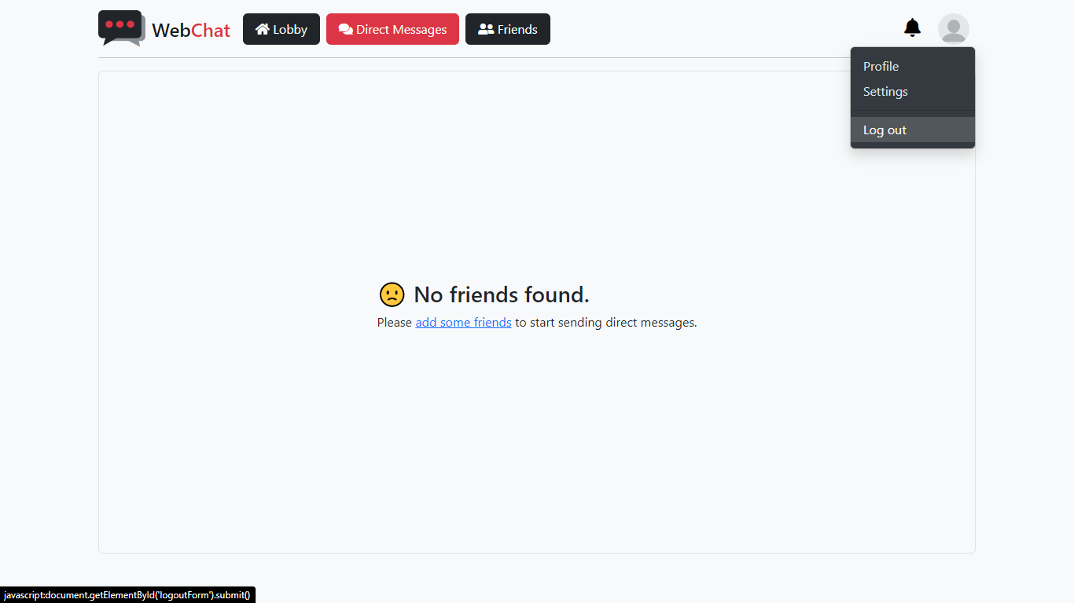

To log out of the site, click on your profile image > and select “Log out.”

### Lobby

If you had opened the website directly, then after signing in, you should be redirected to the Lobby, the home of this web app where all users can chat with each other.



In the Lobby, you can send messages to everyone using the message box at the bottom of the page and click on the send button or simply hit Enter on your keyboard.

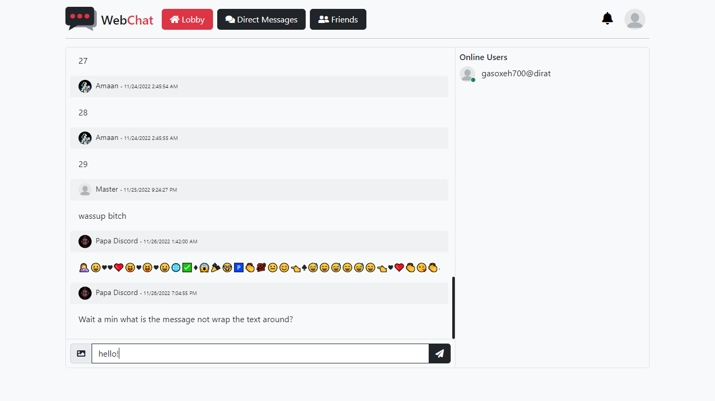

This is how your message will look to you.

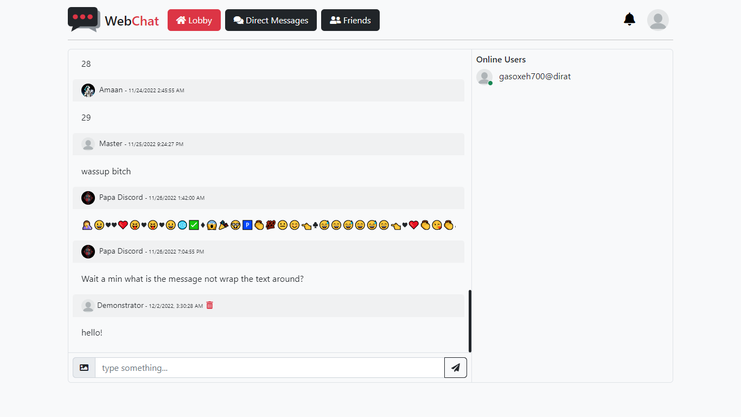

You can also upload images and preview them before sending.

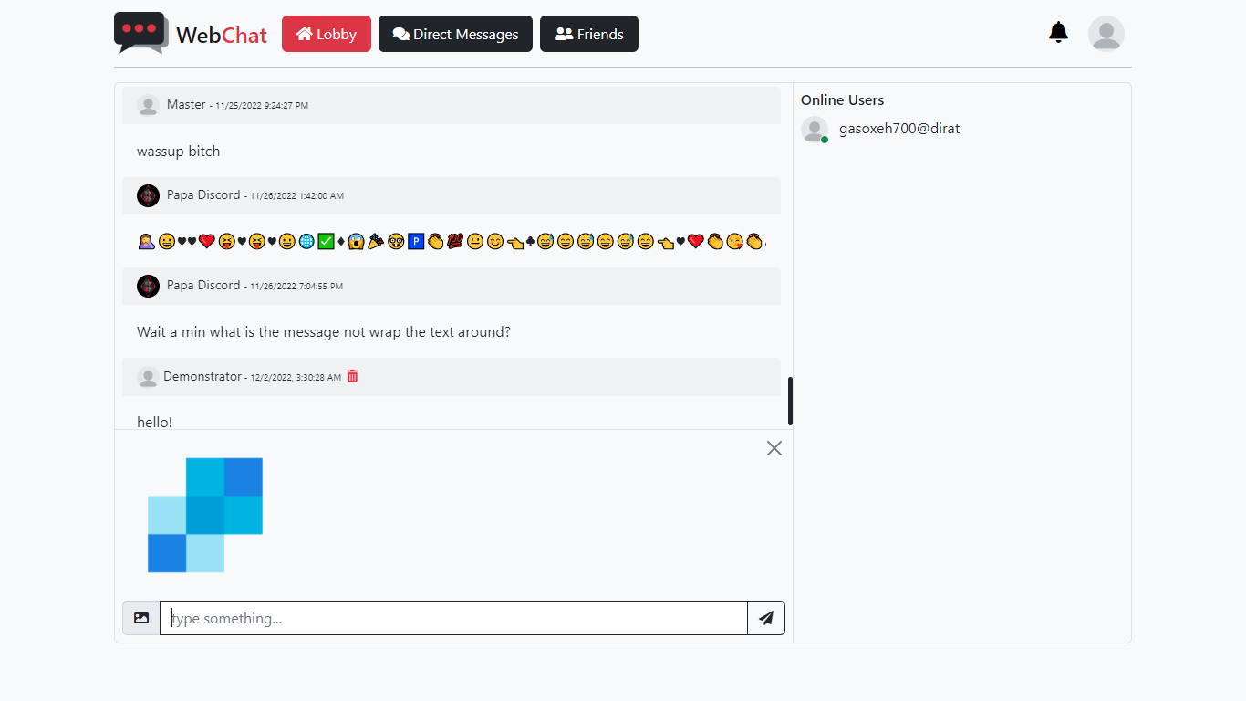

You can choose to send images only or with text messages. There’s also a limit of 40KB when sending images in chat.

In case you want to change the image or remove it, you can remove the selected image from your message by clicking the “X” button on top-right corner in the image preview box.



As of now, you can only post only one image at a time.

You can delete a message by clicking on the trashcan icon next to your name.

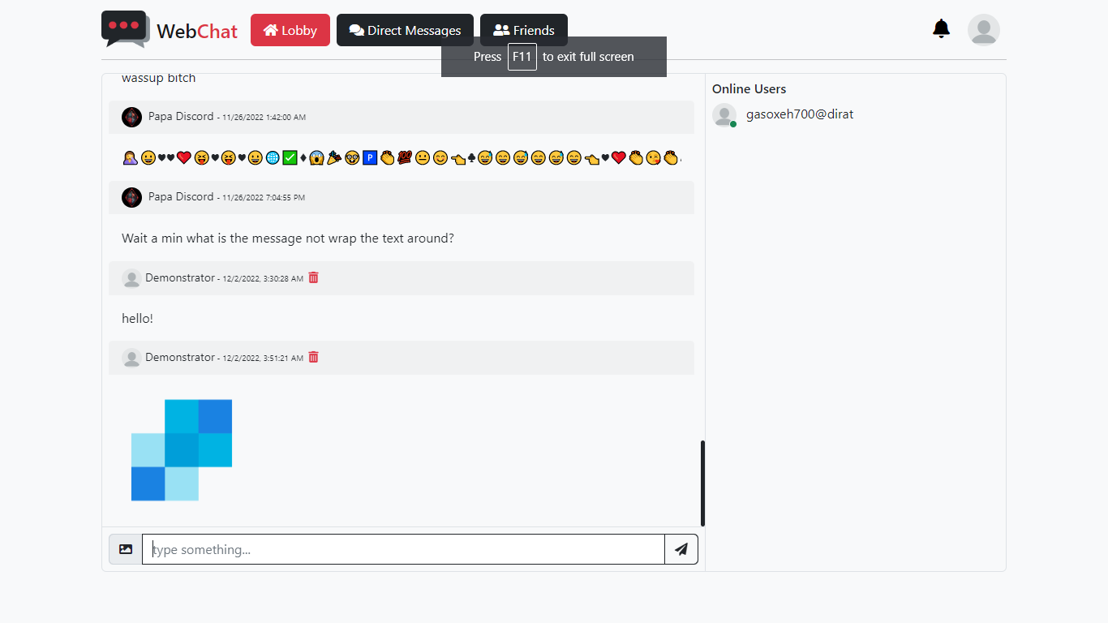

You will be asked to confirm the delete message request.

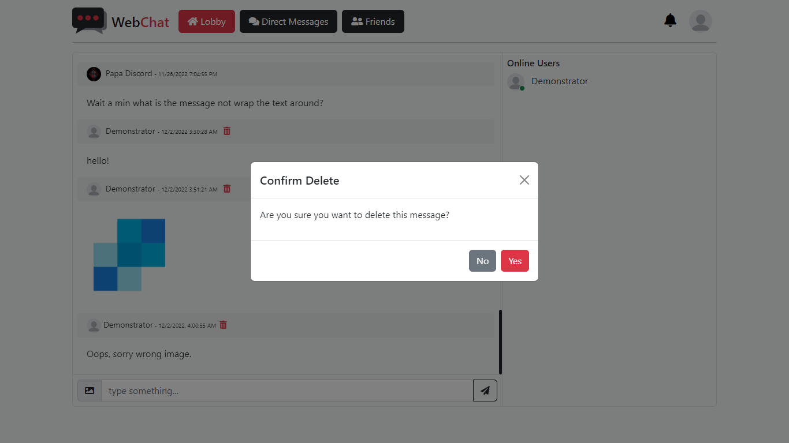

Click “Yes” to delete the selected message or “No” to cancel and go back.

### Friends

You need friends to able to use the Direct Messages feature.

This is how what friends page will look like when you create a new account. No friends.

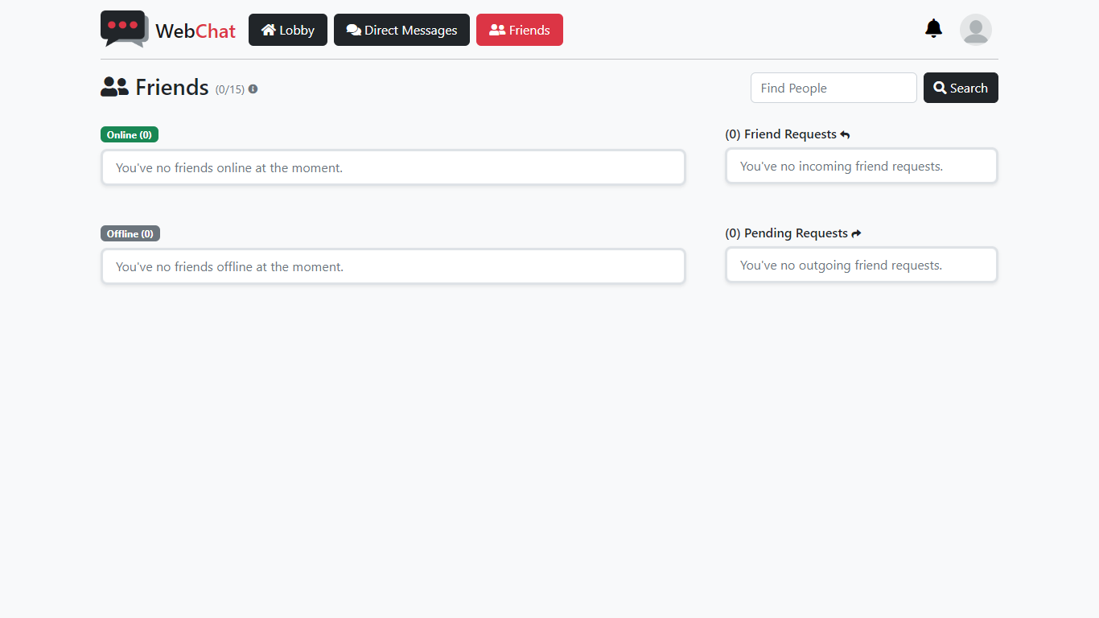

To send a friend request to a user, you need to search for that user. Use the search box to search for a user.



You can search users by their username (DisplayName) or email.

If a user is found with a name or email that matches the search query, a modal will pop up with all users found in our database.

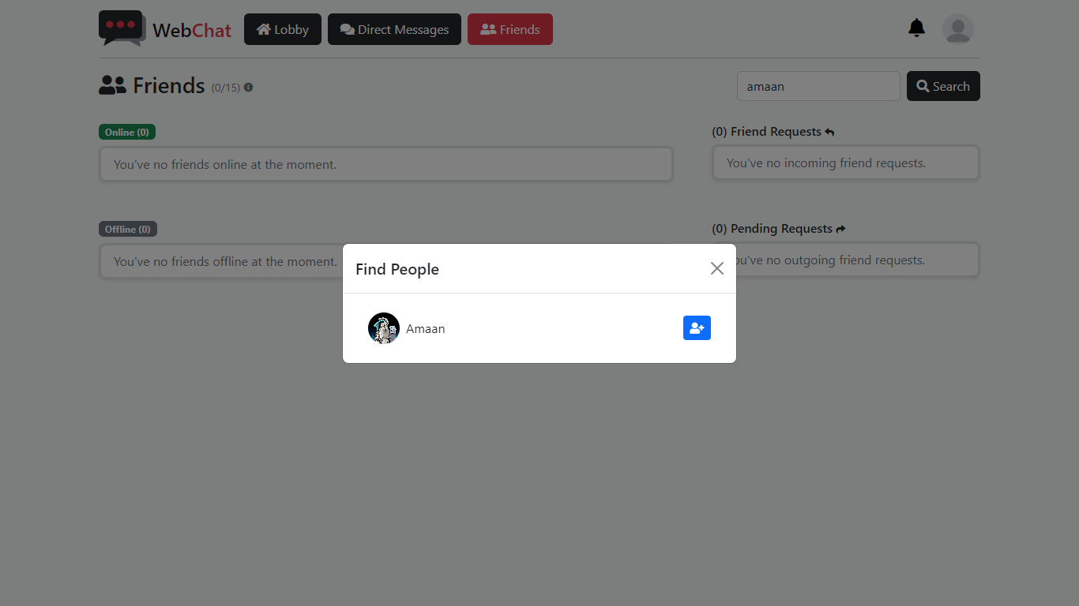

Click on the blue button next to the user you want send friend request to.

Successfully sending a friend request to a user will show you this message.

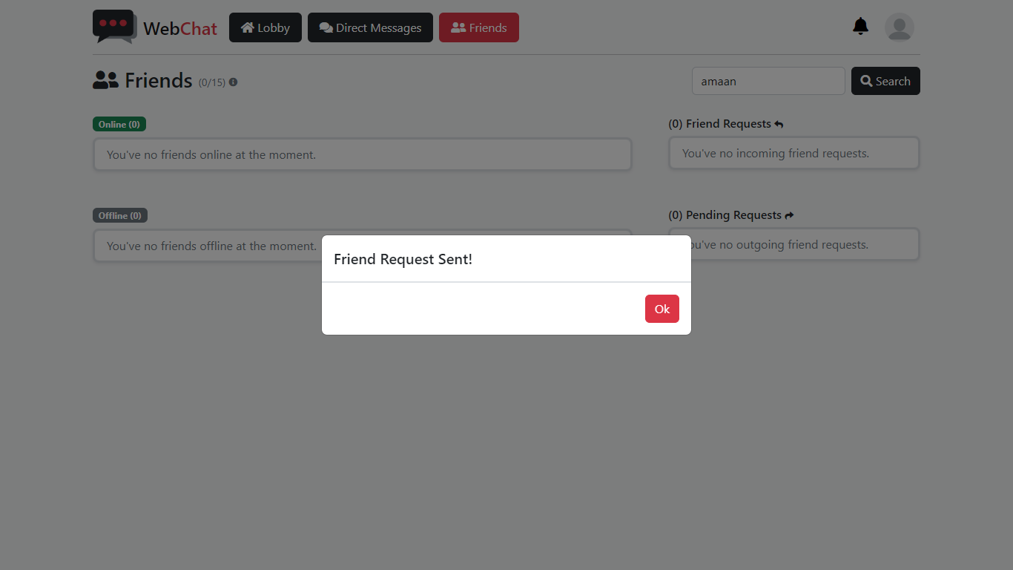

And that user to your pending requests list.

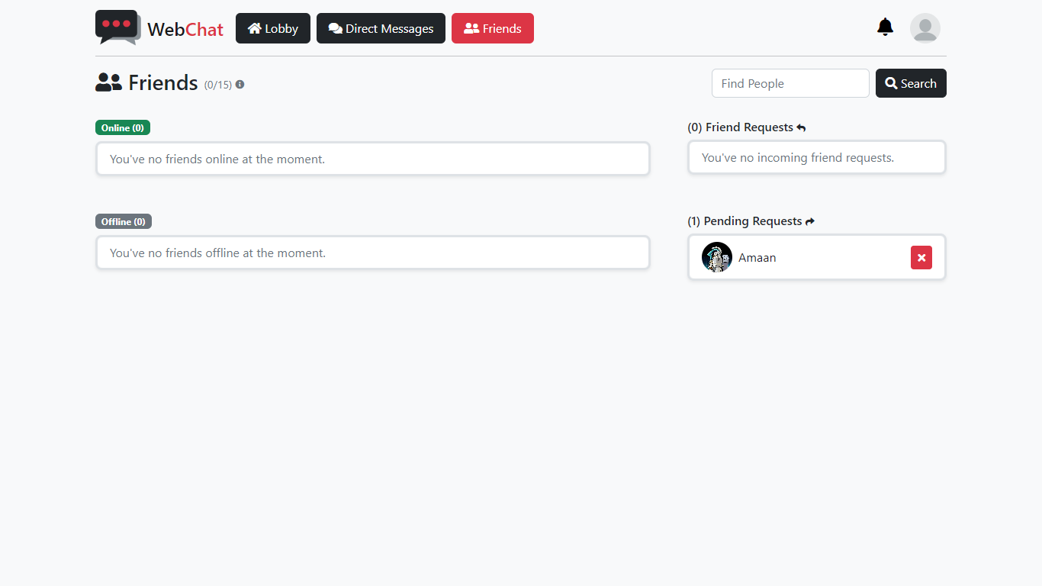

If you want to cancel your friend request, click on the button shown on the image above.

When someone sends you a friend request, it will display under “Friend Requests.”

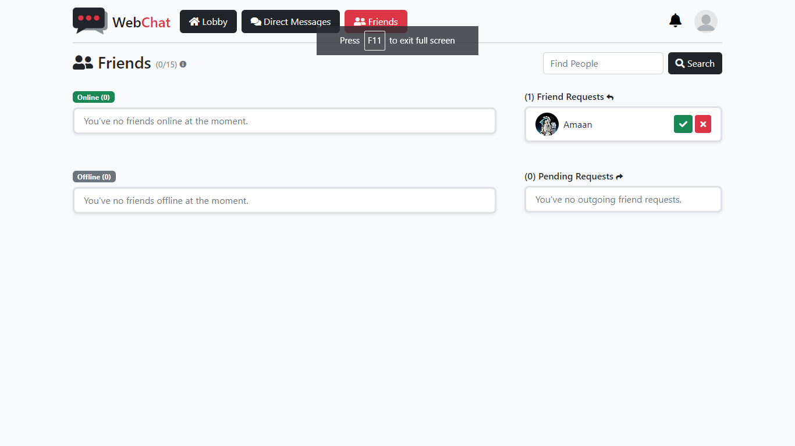

You can either choose to accept their friend by clicking on green-check button or deny with the red-cross button.

Accepting the friend request will add the user to your friends’ list and you will be able to send them direct messages.

### Direct Messages

Direct Messages are used to send private messages to users on your friends’ list that can read by only you and your friend.

If you’re not friends with anyone, this is what your Direct Messages will look like.

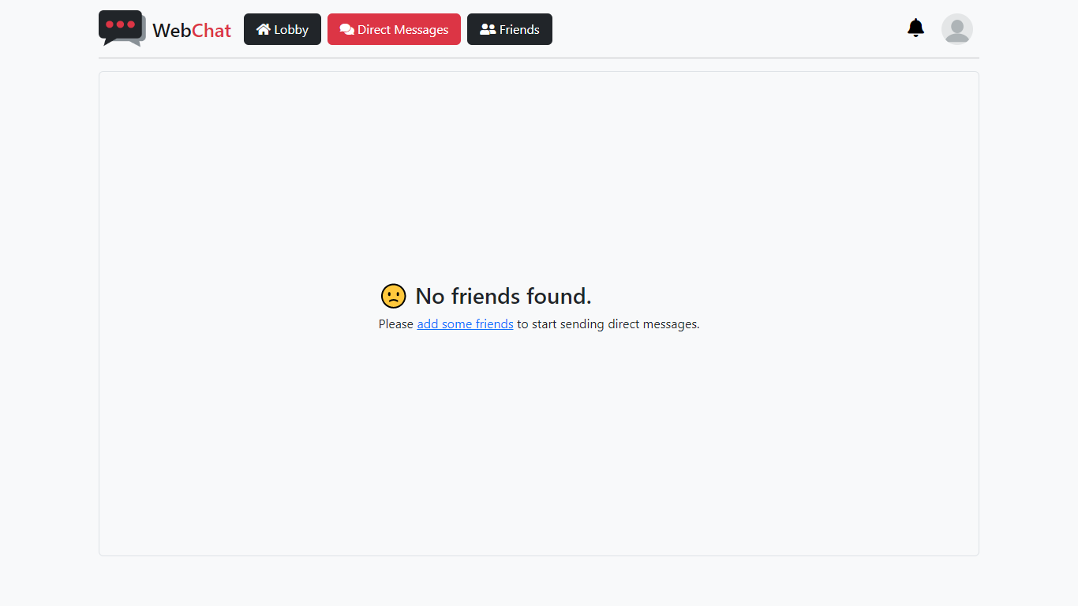

Add someone to your friends’ list to be able to use this feature.

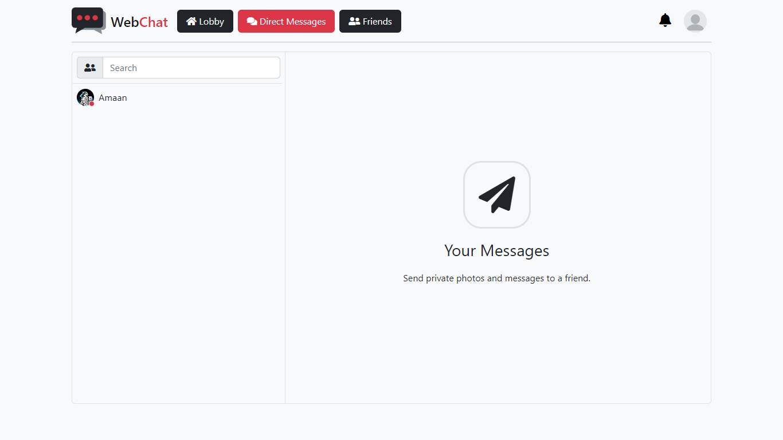

To message a friend, simple click on their name to open the direct messages box.

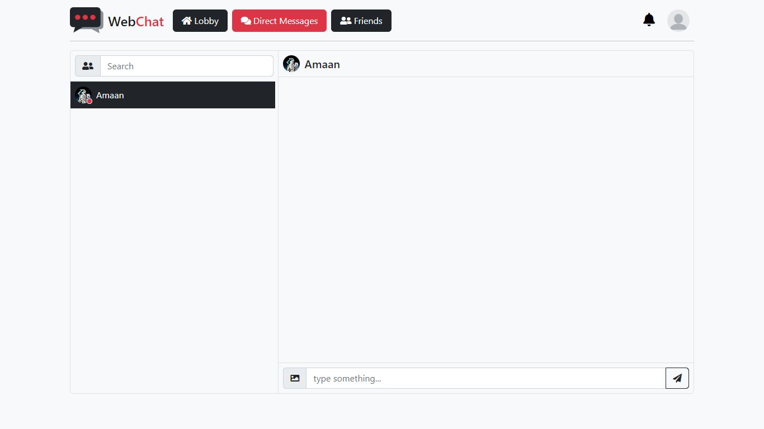

The rest is same as the Lobby.

### Profile

If you want to update your profile picture or set a different username. Account profile settings is your place.

To view and edit your profile, click on your profile icon, on top-right corner of the page on Desktop mode and select “Profile.”

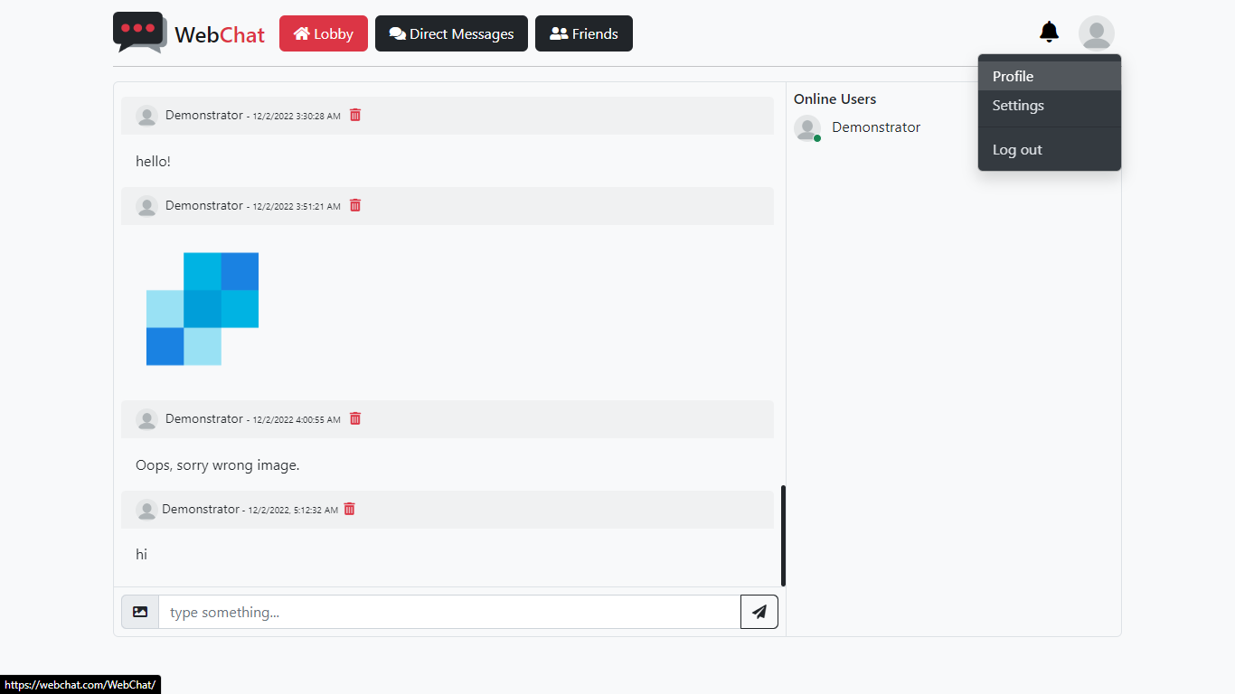

Mobile version is a little different which will be covered in mobile section later.

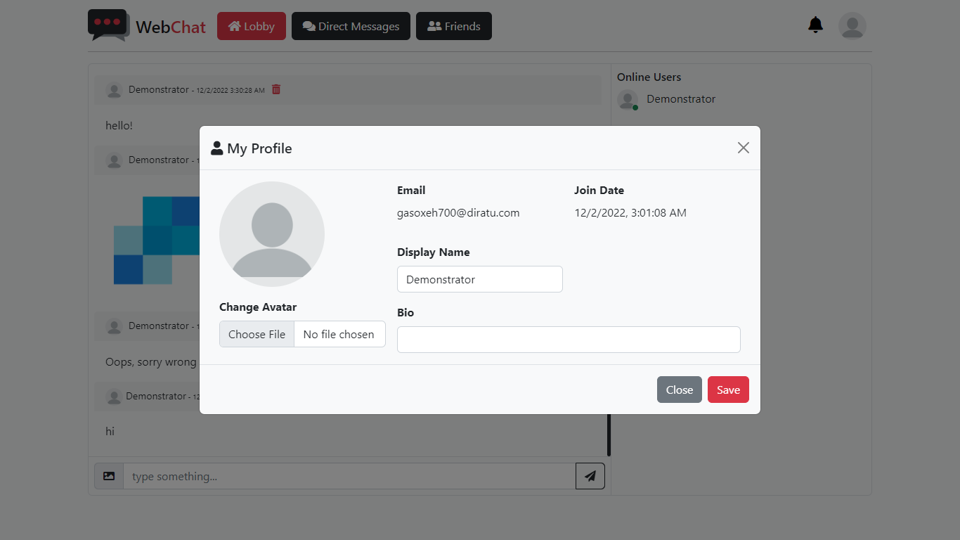

To change your profile picture, click on “Choose file” and upload an image from your device directory.

You can also change your default username which is a part of your email and set a bio if you want.

Click “Save” to update your profile.

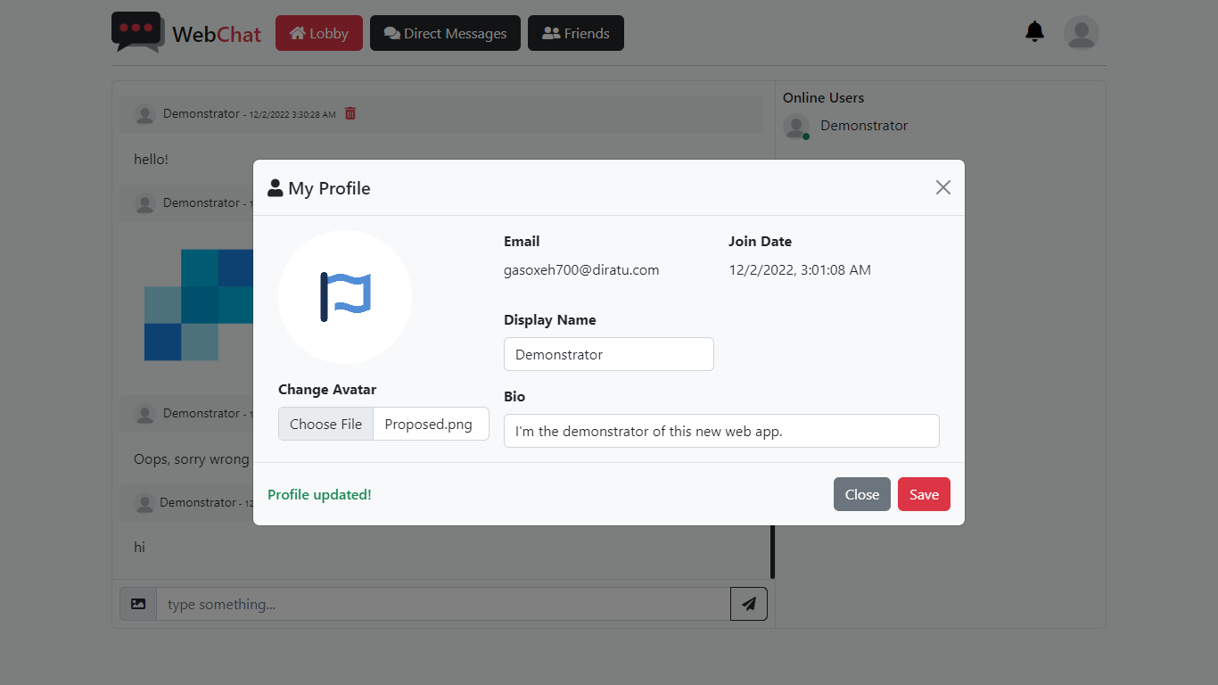

If everything is fine, your profile should update successfully and display a message on the bottom-left of the modal in green for success and red if any error occurs while updating your profile.

### Account Settings

You can change your password, manage linked/external accounts, add a phone number and enable two-factor authentication (2FA) from your account settings.

Click on your profile picture > then on “Settings” to see your account settings.

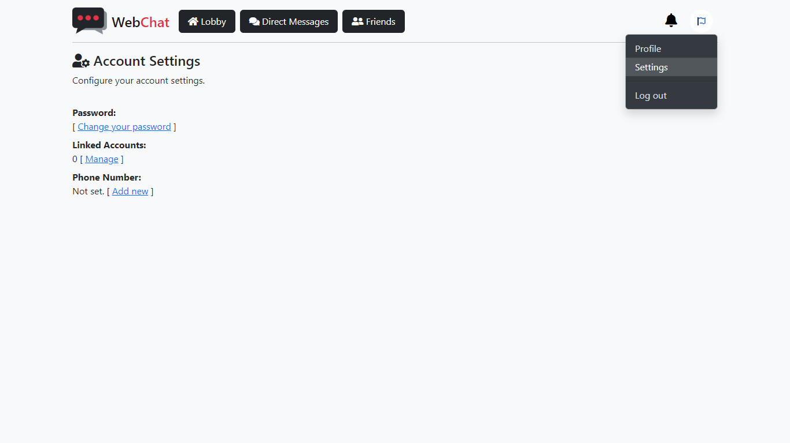

The option to enable 2FA is only available when you add a valid phone number.

To link an external account for quick and easy login, click on “Manage” under “Linked Accounts” on the settings page.

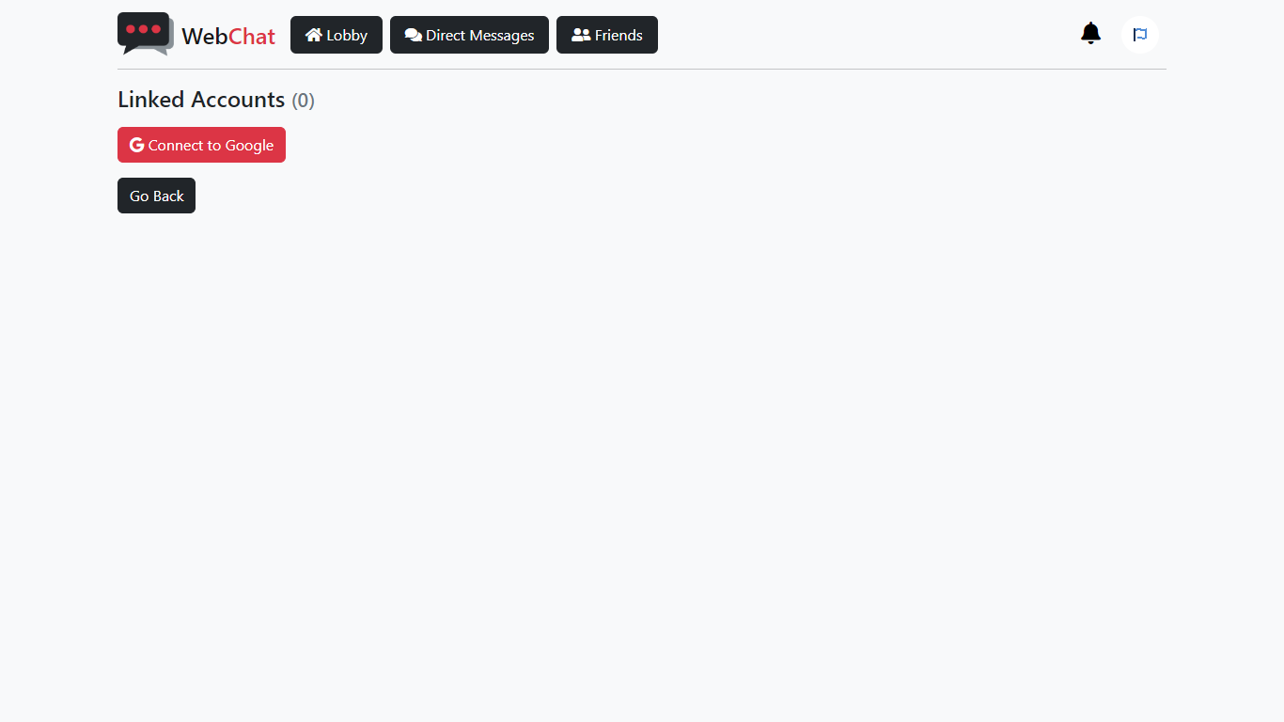

Select the service and go through their authentication process. Once completed, the account will be linked to your WebChat account and you can use that external account to easily login when you come back.

To unlink an external account, simple go back to the linked accounts page from your account settings, and click on unlink.

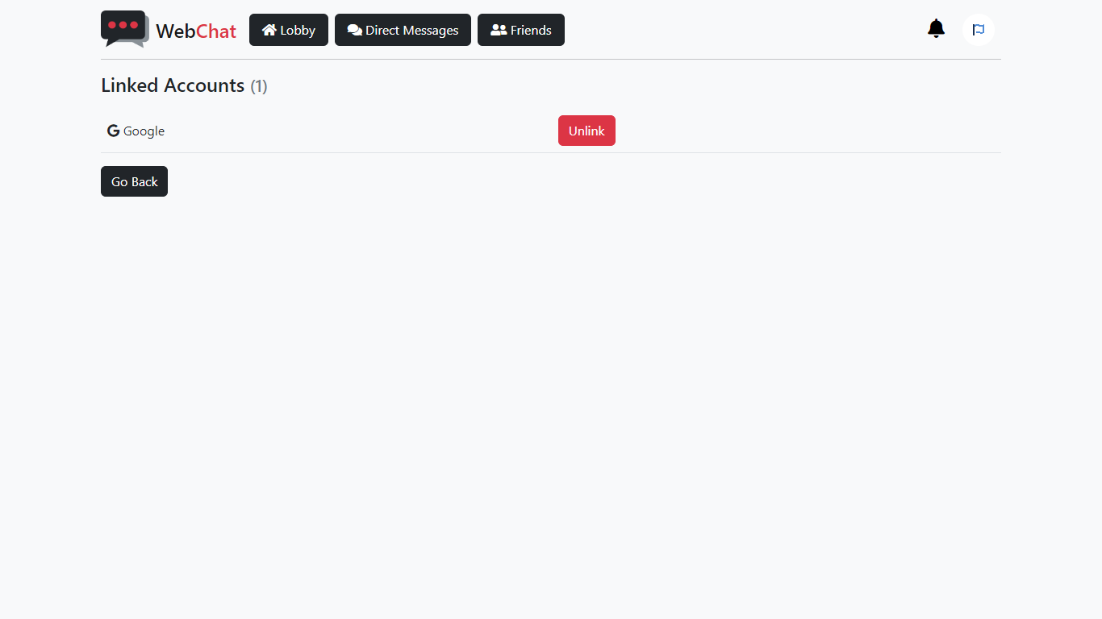

Please note that the option to unlink will be disabled if you used the external account to register with us.

### Mobile

The interface on mobile or small screen devices is a little different from Desktop mode. But all the functions and features remain the same.

This is what you’ll find if you open the site from a mobile.

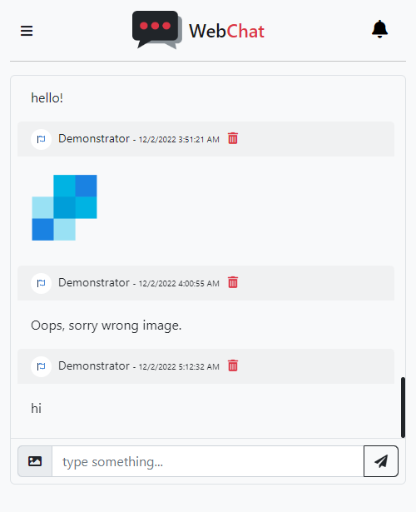

To see the navigation pane, click on the button on top-left corner of the page.



This will open a sidebar on the left of the screen which has same all the options as on desktop mode.

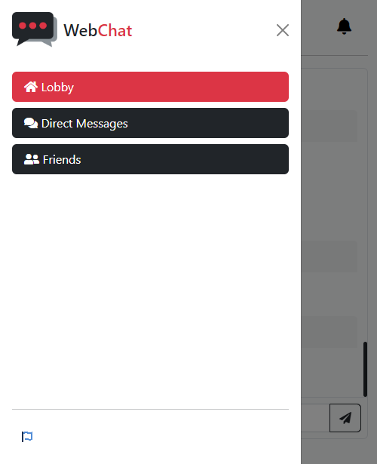

This concludes the demonstration guide for users. Next up we have a guide for developers.

# Developer Guide



**< DEV />**

**GUIDE**



## Aims & Objectives

These are the main goals when changing the contents of this web application.

* Security of the accounts and their data.
* Ease of use of application.
* Website responsiveness across all devices and browsers.
* Smooth behavior of controls, settings, and functions.
* Error handling, both client and server side, across all devices, browsers and other supported platforms.
* Less data consumption.
* Better performance and benchmark.
* Privacy of user data and their activities.
* User management done on web as much as possible.
* Backup and restore point of everything.

(ASP.NET, n.d.)

(Web Development with ASP.NET MVC and Core, 2022)

(Final Report Structure In Computing Project, 2023)

## Prerequisites

This web application is created using ASP.NET MVC 5. Here are the softwares, programs and languages used to create this application.

Softwares & Programs

Programming Languages

|  |  |  |  |
| --- | --- | --- | --- |
|  |  |  |  |

Other Libraries

|  |  |  |  |
| --- | --- | --- | --- |
|  |  |  |  |
| **Version** | 3.6.0 | 5.2.1 | 5.15.4 |

(ASP.NET, n.d.)

(SQL Server, 2022)

(Web Development with ASP.NET MVC and Core, 2022)

### Installing Visual Studio

When installing Visual Studio, make sure these options are checked.

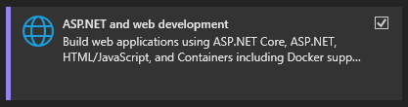

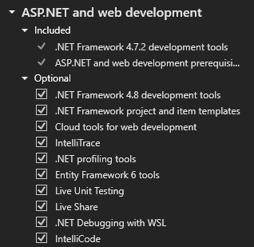

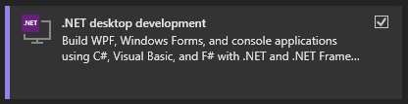

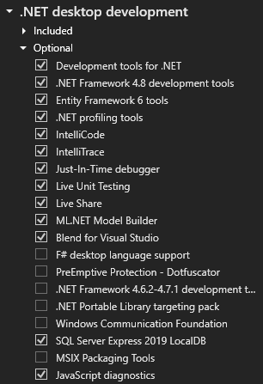

### Installing SQL Server

When installing SQL Server, make sure to choose **Mixed Mode** for **Database Engine Configuration**.

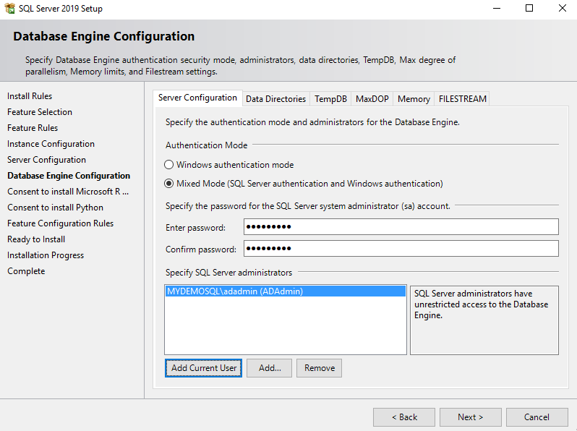

## Integrations

SignalR

SendGrid

## Application Contents

Discover what’s included in WebChat.

**Note:** Only editable files are displayed on the tree below. Do not touch any other file you find inside the application that is not listed below.

WebChat _____________________________________

|  |  |
| --- | --- |
| * App_Start   + BundleConfig.cs   + IdentityConfig.cs   + Startup.Auth.cs * Content   + Site.js * Controllers   + AccountController.cs   + DirectMessagesController.cs   + FriendsController.cs   + HomeController.cs   + ManageController.cs   + ProfilesController.cs * Models   + DirectMessages.cs   + IdentityModel.cs   + Messages.cs   + Profiles.cs   + ViewModel.cs * Scripts   + Site.js * Chathub.cs * Startup.cs * Web.config | * Views   + Account     - _ExternalLoginsListPartial.cshtml     - ConfirmEmail.cshtml     - ConfirmEmailInfo.cshtml     - ExternalLoginConfirmation.cshtml     - ExternalLoginFailure.cshtml     - ForgotPassword.cshtml     - ForgotPasswordConfirmation.cshtml     - Login.cshtml     - Register.cshtml     - ResetPassword.cshtml     - ResetPasswordConfirmation.cshtml     - SendCode.cshtml     - VerifyCode.cshtml   + DirectMessages     - Index.cshtml   + Friends     - Index.cshtml   + Home     - Index.cshtml   + Manage     - AddPhoneNumber.cshtml     - ChangePassword.cshtml     - Index.cshtml     - ManageLogins.cshtml     - SetPassword.cshtml     - VerifyPhoneNumber.cshtml   + Profiles   + Shared     - _Layout.cshtml     - _LoginPartial.cshtml     - Error.cshtml     - Lockout.cshtml |

## Database Contents

1. Users Table [dbo.AspNetUsers]

|  |  |  |
| --- | --- | --- |
| **Name** | **Data Type** |  |
| Id | nvarchar(128) |  |
| Email | nvarchar(256) |  |
| EmailConfirmed | bit |  |
| PasswordHash | nvarchar(max) |  |
| SecurityStamp | nvarchar(max) |  |
| PhoneNumber | nvarchar(max) |  |
| PhoneNumberConfirmed | bit |  |
| TwoFactorEnabled | bit |  |
| LockoutEndDateUtc | datetime |  |
| LockoutEnabled | bit |  |
| AccessFailedCount | int |  |
| UserName | nvarchar(256) |  |

1. External Logins Table [dbo.AspNetUserLogins]

|  |  |  |
| --- | --- | --- |
| **Name** | **Data Type** |  |
| LoginProvider | nvarchar(128) |  |
| ProviderKey | nvarchar(256) |  |
| UserId | bit |  |

1. User Profiles Table [dbo.Profiles]

|  |  |  |
| --- | --- | --- |
| **Name** | **Data Type** |  |
| Email | nvarchar(256) |  |
| JoinDate | datetime |  |
| DisplayName | nvarchar(16) |  |
| Avatar | varbinary(max) |  |
| Bio | nvarchar(200) |  |
| Status | varchar(50) |  |
| Friends | nvarchar(max) |  |
| OutgoingFriendRequests | nvarchar(max) |  |
| IncomingFriendRequests | nvarchar(max) |  |

1. Lobby Messages Table [dbo.Messages]

|  |  |  |
| --- | --- | --- |
| **Name** | **Data Type** |  |
| MsgID | int |  |
| Msg | nvarchar(max) |  |
| Img | varbinary(max) |  |
| Email | nvarchar(256) |  |
| DateTime | datetime |  |

1. Direct Messages Table [dbo.DirectMessages]

|  |  |  |
| --- | --- | --- |
| **Name** | **Data Type** |  |
| Id | int |  |
| Sender | nvarchar(256) |  |
| Receiver | nvarchac(256) |  |
| Msg | nvarchar(max) |  |
| Img | varbinary(max) |  |
| DateTime | datetime |  |

## ER Diagram

|  |  |
| --- | --- |
| **AspNetUserLogins** | |
|  | LoginProvider |
|  | ProviderKey |
|  | UserId |

|  |  |
| --- | --- |
| **AspNetUsers** | |
|  | Id |
|  | Email |
|  | EmailConfirmed |
|  | PasswordHash |
|  | SecurityStamp |
|  | PhoneNumber |
|  | PhoneNumberConfirmed |
|  | TwoFactorEnabled |
|  | LockoutEndDateUtc |
|  | LockoutEnabled |
|  | AccessFailedCount |
|  | UserName |

|  |  |
| --- | --- |
| **Profiles** | |
|  | Email |
|  | JoinDate |
|  | DisplayName |
|  | Avatar |
|  | Bio |
|  | Status |
|  | Friends |
|  | OutgoingFriendRequests |
|  | IncomingFriendRequests |

|  |  |
| --- | --- |
| **Messages** | |
|  | MsgId |
|  | Msg |
|  | Img |
|  | Email |
|  | DateTime |

|  |  |
| --- | --- |
| **DirectMessages** | |
|  | Id |
|  | Sender |
|  | Receiver |
|  | Msg |
|  | Img |
|  | DateTime |

## Source Code

### ChatHub (SignalR)

**Initializing chat system (SignalR) in ChatHub.cs.**

Setting user’s status to “online” when they connect to the application.

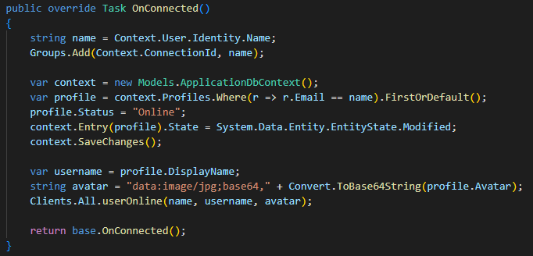

Setting user’s status to “offline” when they disconnect from the application.

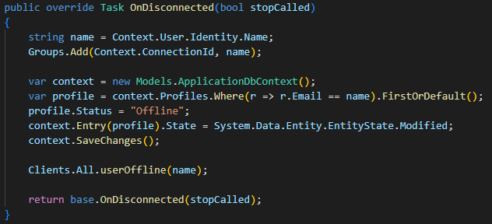

Setting up a function to send messages.

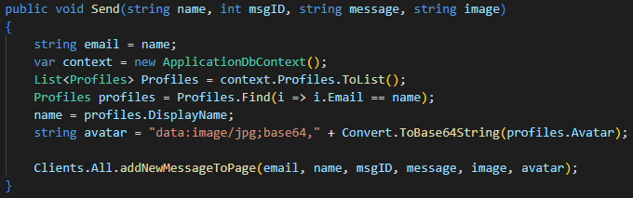

This function will return the sent message to all users.

Setting up Direct Message function.

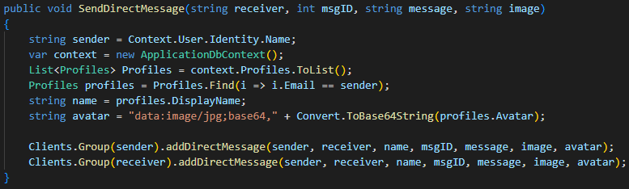

This function will send a message to specific user only.

A function to display user is typing.

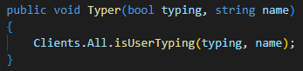

### Lobby

**Setting up the Lobby in Home/Index.cshtml.**

Only three models are used here; AspNetUsers, Profiles, and Messages. Most of the functions are performed client side using Ajax to prevent page refresh and for fast response.

Setting up Home Controller using C#.

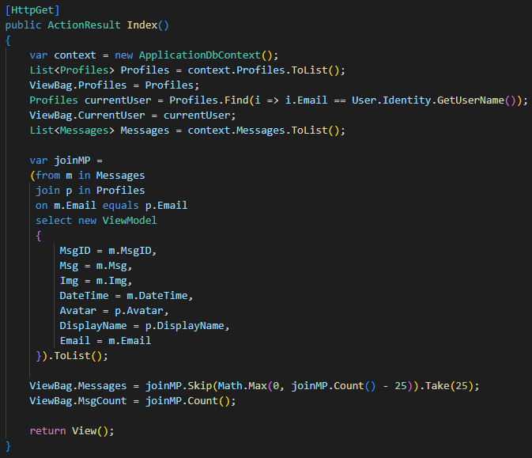

This function loads last 25 messages sent by users in the Lobby.

Defining a function to let users send messages in the Lobby.

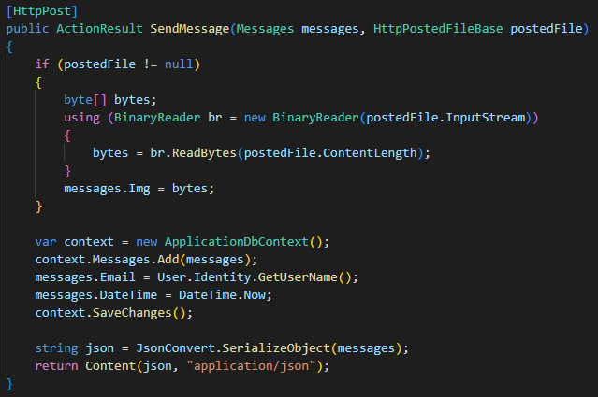

Here, we are posting a message from a form in Index.cshtml which will look soon, and converting the image, if given, to byte and saving in database.

Writing a function to let users delete a specified message that they posted.

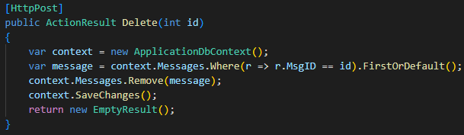

Since the app is only displaying 25 messages on start. Here’s a function to let users load more messages.

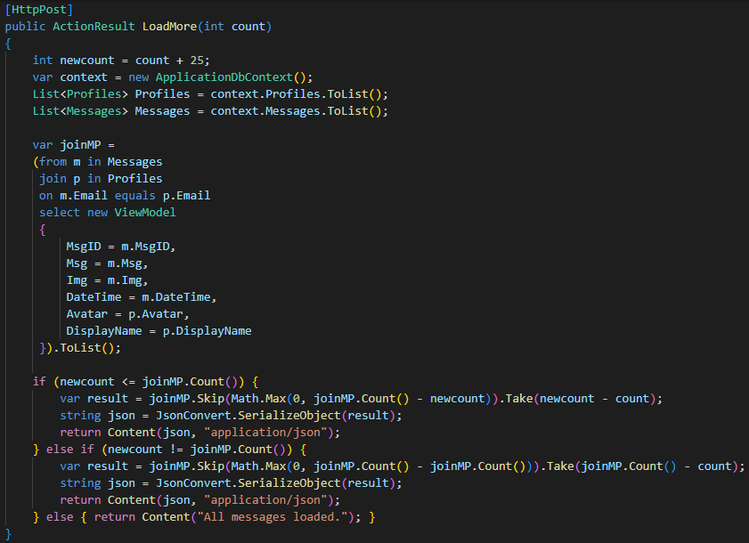

This will also return 25 messages.

**Setting up the views page using HTML and C#.**

Displaying a list of online users which is updated using JavaScript.

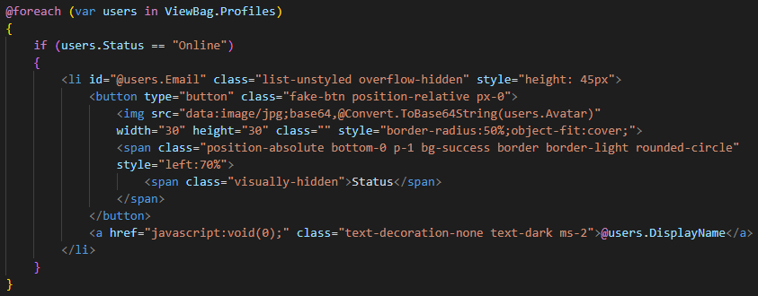

Loading messages which are stored in database when the page loads.

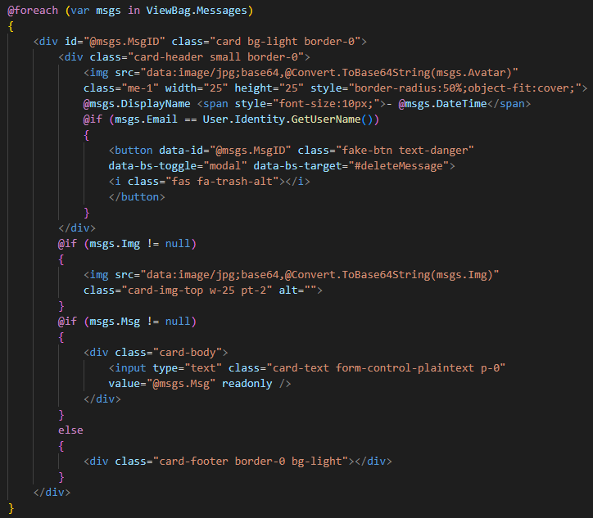

The above code returns the contents of Index Action from the Home Controller.

Since we are displaying only 25 messages when the page is loaded for the first time, we will add a button to load more messages.

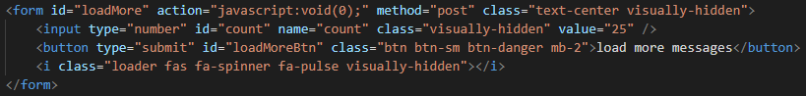

This code returns the content of LoadMore Action defined in the Home Controller.

Adding a form to let users send new messages to the Lobby.

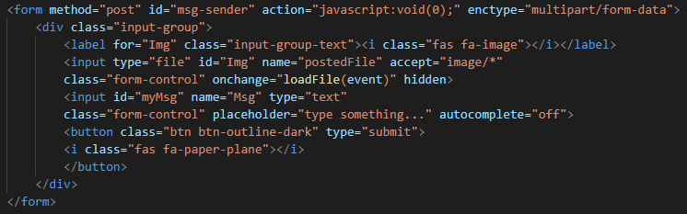

This HTML code is for posting new messages to the Home Controller which is handled by SendMessage Action.

Next up we have JavaScript where we will use ajax methods to request and submit data to or from the server.

Before we setup JavaScript, it is important to render script using this code given below at the bottom of the page to put functions below the shared file scripts.

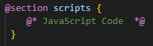

**Setting up JavaScript functions on Index.cshtml.**

Store the ChatHub connection to a variable.



This is important as most of the functions are designed to work in real-time.

Updating the list of online users when a new user joins the Lobby.

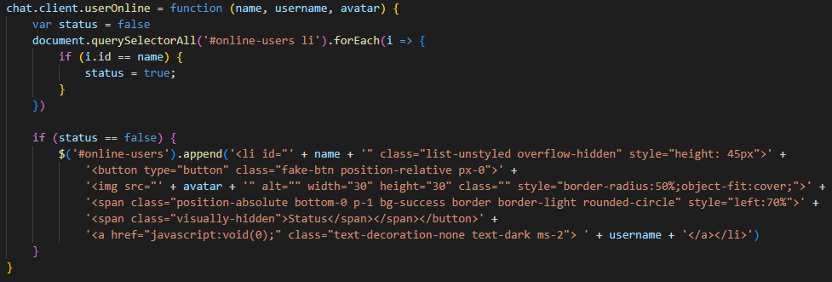

Updating the list of online users when a user leaves the Lobby.

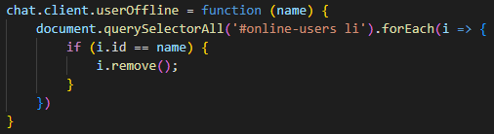

This will the remove the user’s DisplayName and Avatar from the list of online users.

Function to display user is typing in real-time.

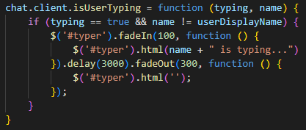

This function is executed when a user presses a key. With the help of a little debounce function, which is given at the end of this section, it prevents from overloading the DOM. Let’s say user is constantly typing, so in order to prevent triggering the function on each key press, we are adding a simple timeout function.

Function to send message.

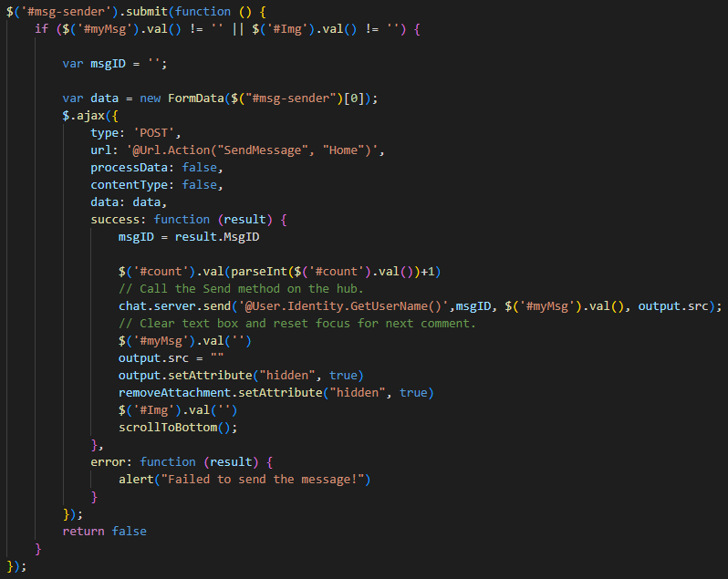

And displaying it to all users in real-time.

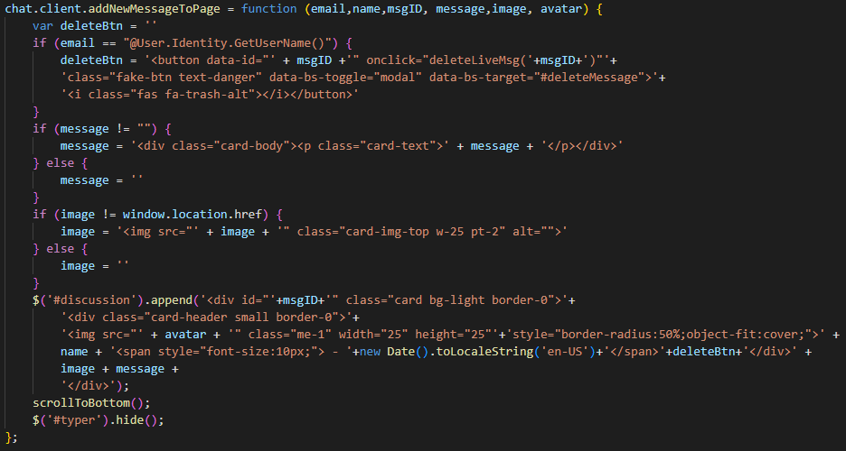

Function for deleting a message.

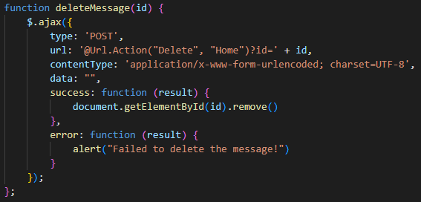

This function is called from Scripts/site.js.

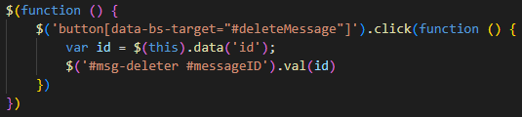 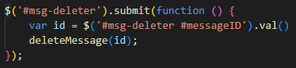

This is connected to the message deletion confirmation modal.

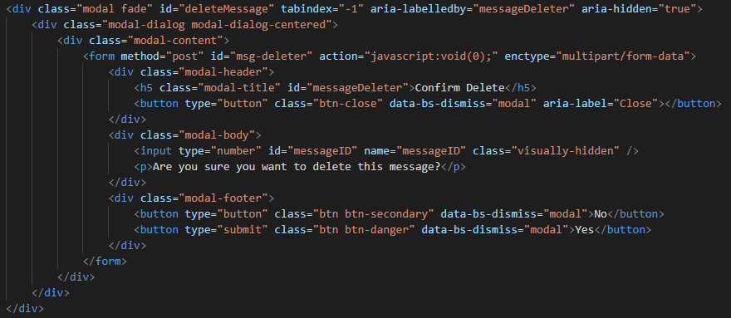

Function assigned to the button for loading more messages.

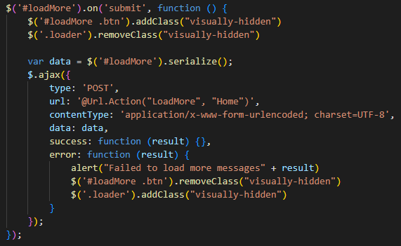

On success, it retrieves more 25 messages in a dictionary from the server which is handles by the Home Controller.

Due to the lengthy size of the code, it is not displayed here. But it is in the same format as when the page is loaded for the first time.

Here’s the debounce function we discussed earlier.

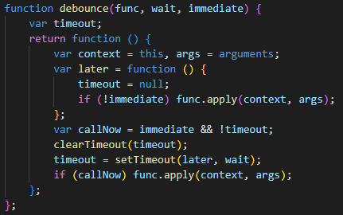

(Polesny, 2021)

### Friends

**Setting up FriendsController.cs.**

Please note that due to lengthy text, codes have been modified and shortened for better understanding.

The is the starting of the first function which is for the default page, Index.cshtml.

This is to retrieve the list of all users who are friends with the current user.

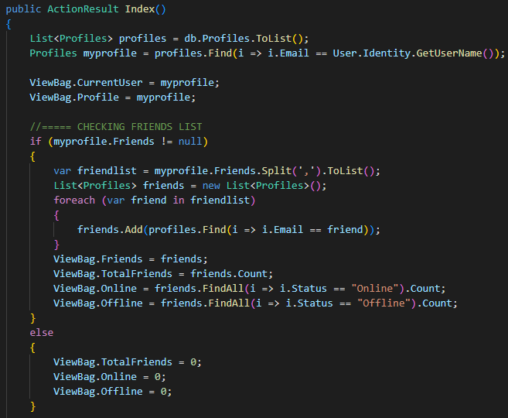

This function returns list of friends and number of friends to the Friends Index page.

Retrieving list of all friend requests sent by other users to current user.

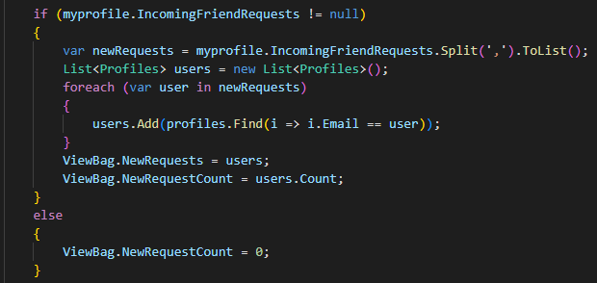

Retrieving list of friend requests sent to other users.

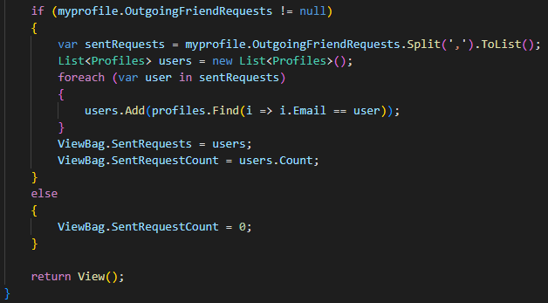

This was the end of first function, Index Action.

**Finding other users on the platform.**

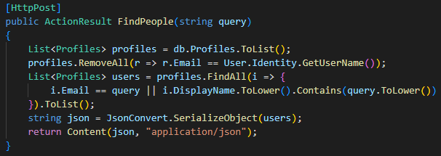

This function will search for users with given DisplayName or Email.

**Sending a friend request.**

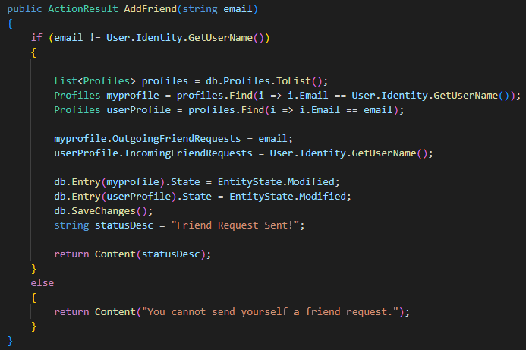

This function will add the other user’s email to current user’s OutgoingFriendRequests list and current to user’s email to other user’s IncomingFriendRequests list.

**Cancelling sent request.**

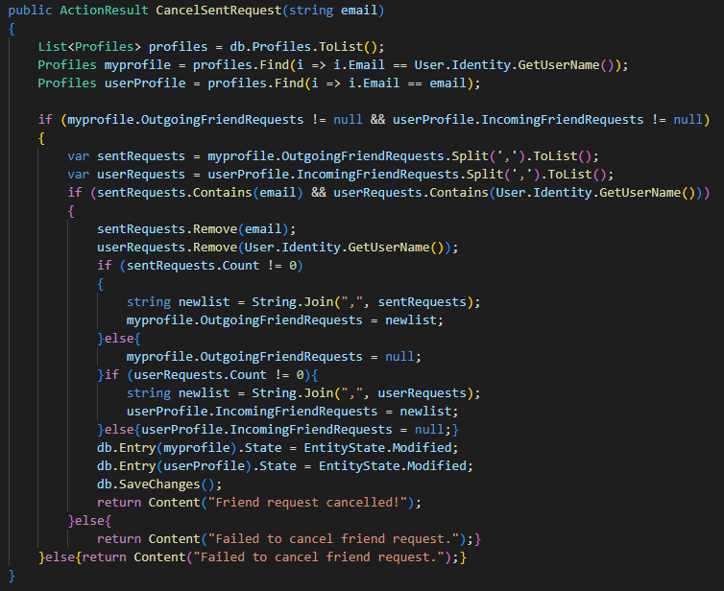

**Accepting Friend Request.**

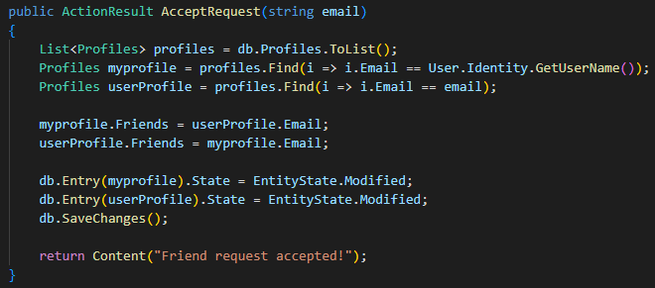

**Denying Friend Request.**

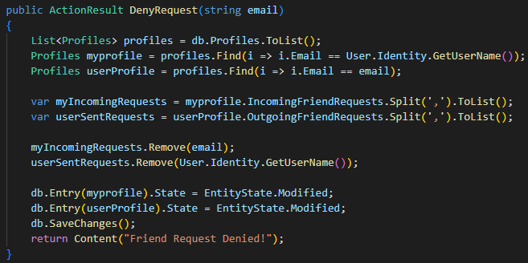

**Remove a user from Friend list.**

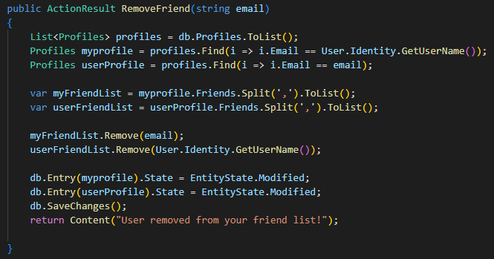

**Setting up Friends view page - Views/Friends/Index.cshtml.**

Similar to the Index page in Home, this also uses C#, HTML and JavaScript.

**User Search Form.**

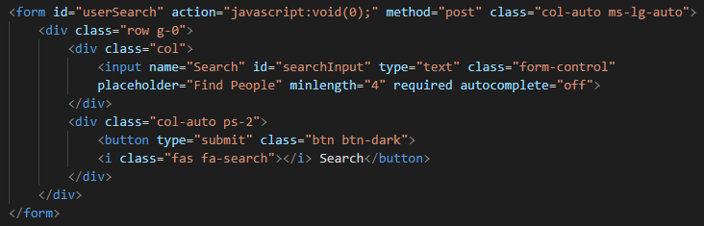

**Display list of Online Friends.**

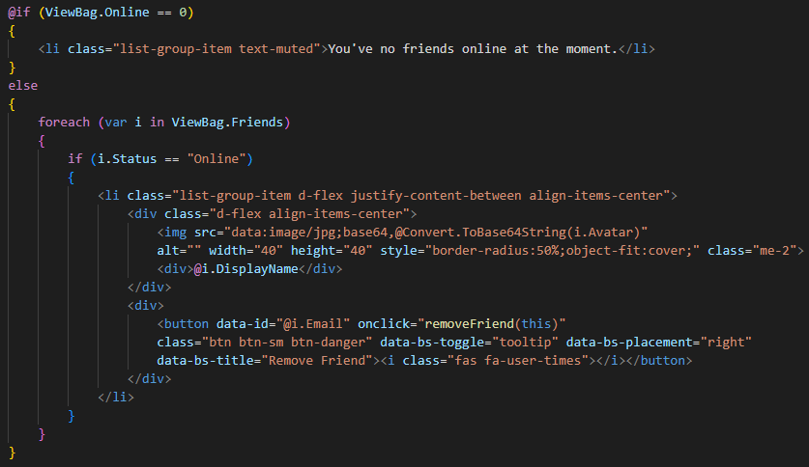

**Display List of Offline Friends.**

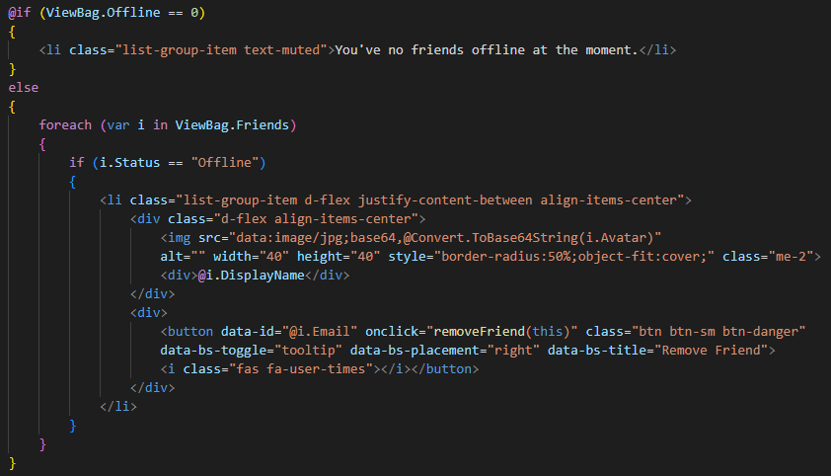

**Display Incoming Friend Requests.**

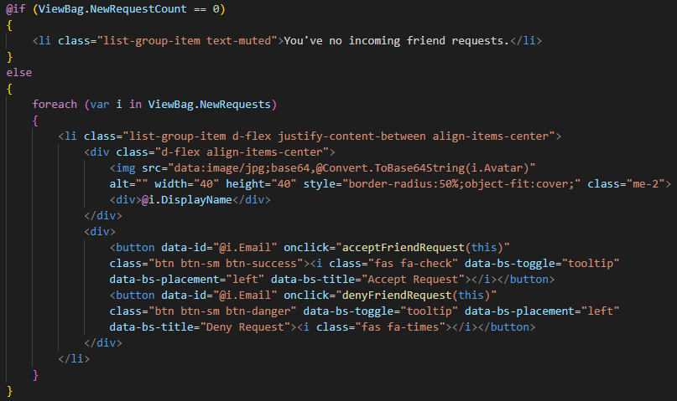

**Display list of sent requests.**

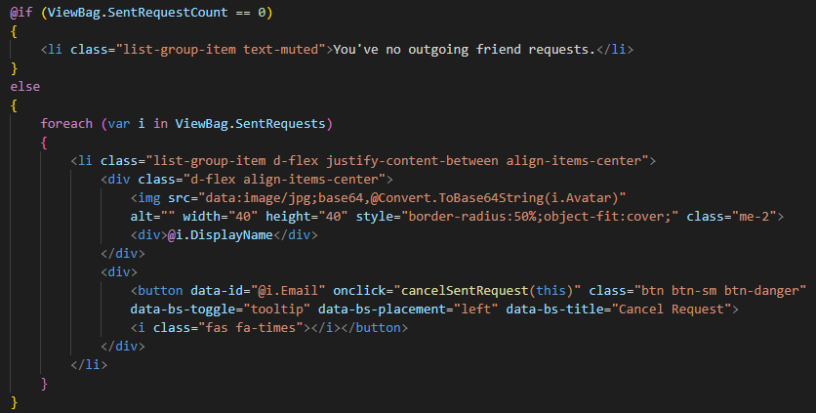

**JavaScript function for sending a new friend request.**

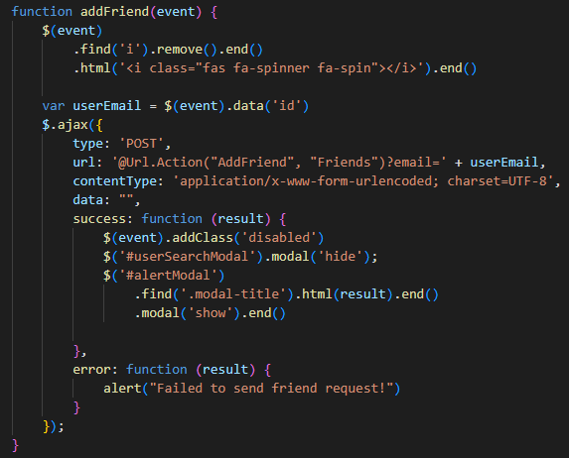

**Ajax function for searching a user in the database.**

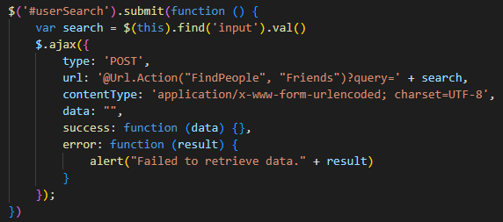

On success:

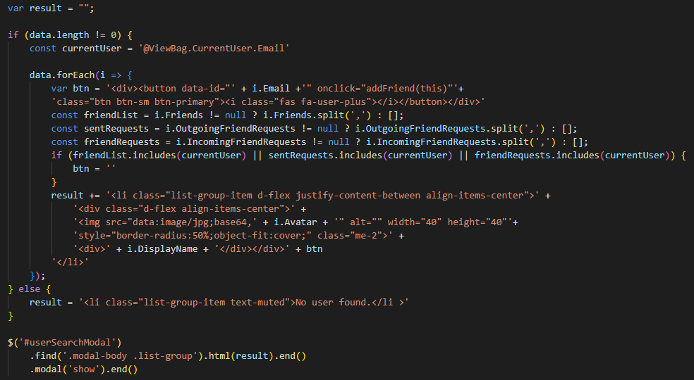

**JavaScript function for cancelling a sent request.**

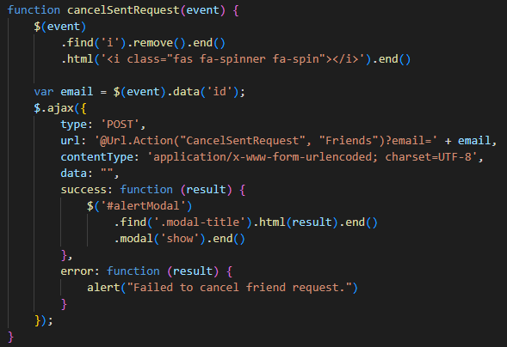

**JavaScript function for accepting a friend request.**

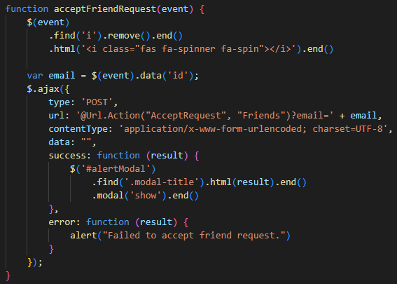

**JavaScript function for denying friend request.**

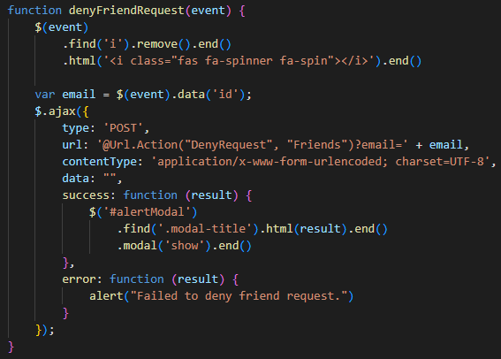

**JavaScript function for removing a user from friend list.**

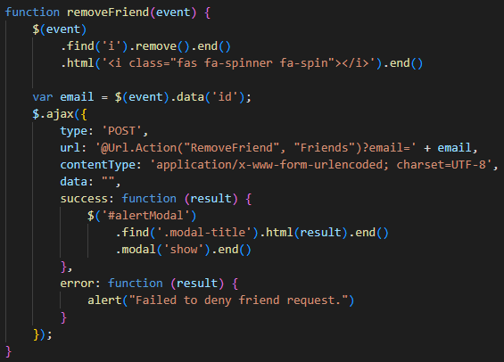

### Direct Messages

**Setting up DirectMessagesController.cs**.

Direct Messages is connected and based on friend system. User can only send direct messages to those who are added in their friend list.

Function to retrieve all users from friend list.

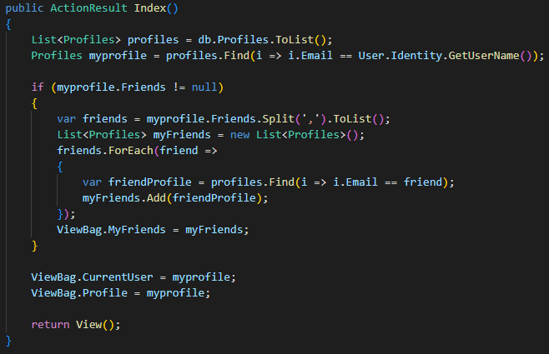

This function will show all users to whom the current user can send private messages.

Next up we have retrieving and sending messages just like Lobby except they are limited to user’s friend circle.

**Send Direct Message.**

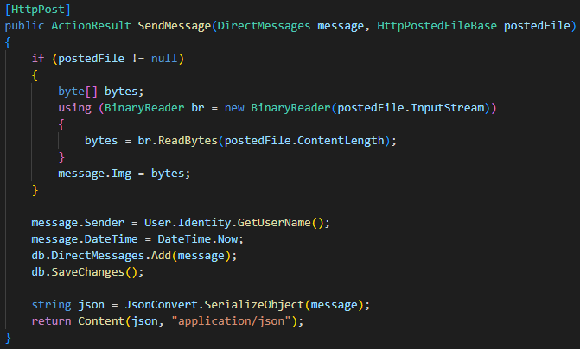

**Get whole conversation between two users.**

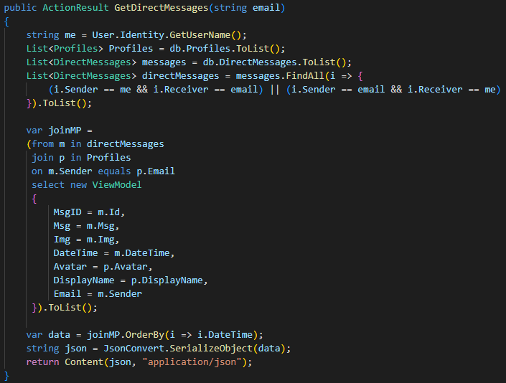

**Delete a private message.**

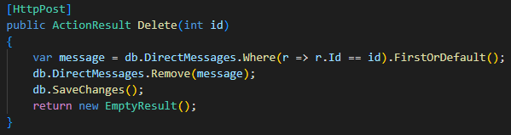

This function is same as the one defined in the Home Controller. It deletes an entry from the DirectMessages table.

**Setting up DirectMessages/Index.cshtml.**

If the user’s friend list is empty, it will display the code below.

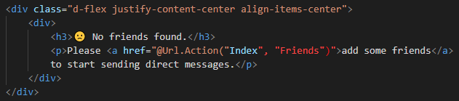

If the user has friends, this code will display the list of friends.

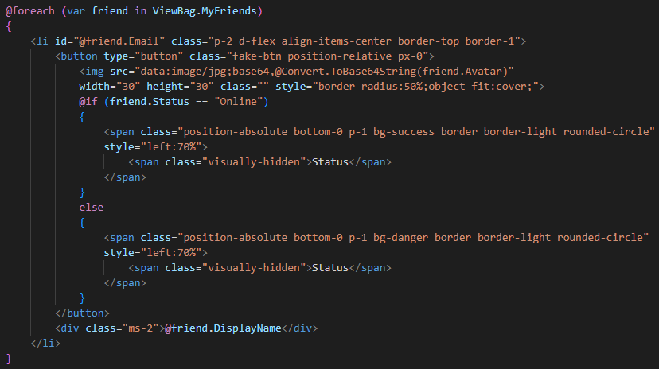

When the user clicks on a friend’s name, the page will display the send message form, similar to the one we have in Lobby.

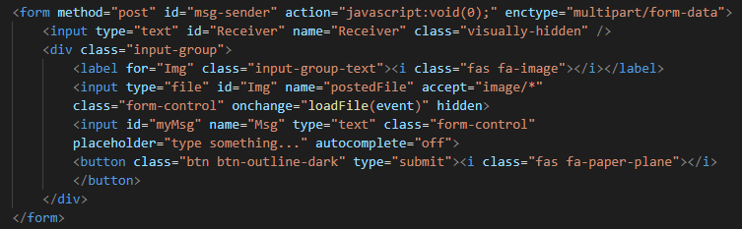

The JavaScript part is same as for Lobby except it simply interacts with the DirectMessages Controller. Therefore, I’m going to skip adding JS codes here.

However, the design of DirectMessages page changes when on smaller screen devices. The screen size change movements are controlled from JavaScript.

Here’s the code for it. This function simply hides friends list and display chat screen. The rest is same as in the Lobby.

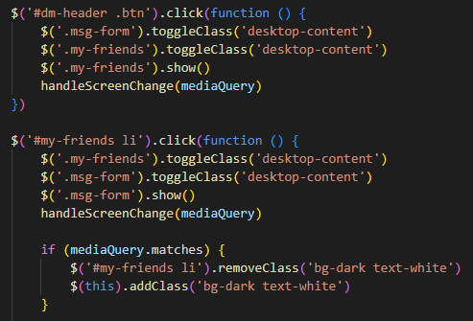

## Deployment

### Running or Debugging on a Single Machine

To debug the project, open the solution file from Visual Studio or directly from WebChat > WebChat.sln.

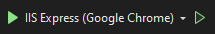

Use either of the buttons show in the image above to run the program without publishing.

A test account has been provided with the app to validate the connection.

|  |  |  |
| --- | --- | --- |
| **Account Credentials** | | |
| **Email** | **:** | **amaan@mail.com** |
| **Password** | **:** | **Amaan@12345** |

Use this account to log in and test if you are successfully connected to SQL server.

If logged in successfully, the database should be created automatically inside your SQL Server LocalDb.

To access the database from SQL Server, open SSMS (SQL Server Management Studio) and connect to the server using the credentials given below.

|  |  |  |
| --- | --- | --- |
| **Server Name** | **:** | **(LocalDb)\MSSQLLocalDB** |
| **Authentication** | **:** | **Windows Authentication** |

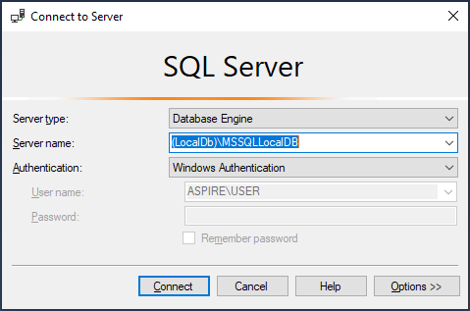

Click on “Connect” to connect to the server.

You must see a database named “WebChat” under Databases inside the Object Explorer.

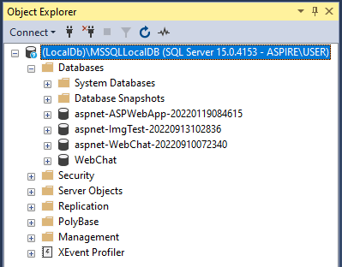

(SQL Server, 2022)

(Web Development with ASP.NET MVC and Core, 2022)

### Deploying on IIS (Local Network)

**# Step 1. Enable IIS on Windows.**

Open **Control Panel** > **Programs** > **Programs and Features** > **Turn Windows features on or off**.

Expand **Internet Information Services** and tick **Web Management Tools** and **World Wide Web Services** folder and all subfolders inside them.

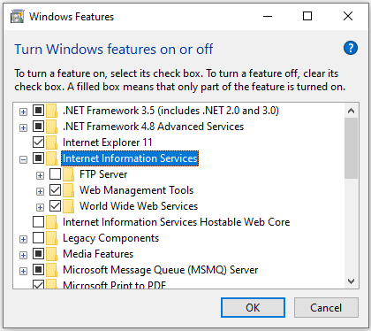

Select **OK**. A Dialog box indicating installation is taking place should appear.

Run the IIS Manager to verify the installation was successful.

(Dykstra, 2022)

**# Step 2. Publish the web application to IIS folder using Visual Studio.**

In Solution Explorer, right-click the project and select “Publish” or click on “Build” on the top menu and select “Publish WeChat.”

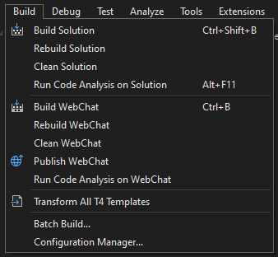

If you're publishing for the first time, you should see the Publish wizard open automatically. If not, click on “Add a publish profile” inside the Publish tab.

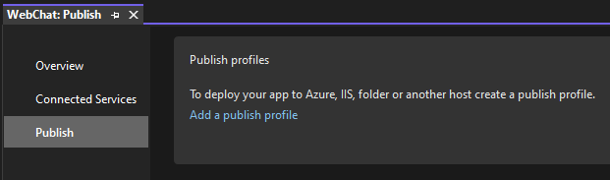

Then select the Folder option and click on Next.

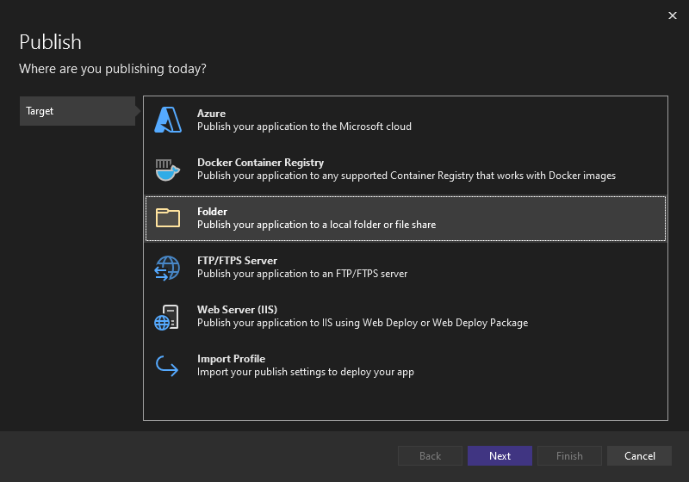

In the next screen, choose or create a new folder and click on Finish.

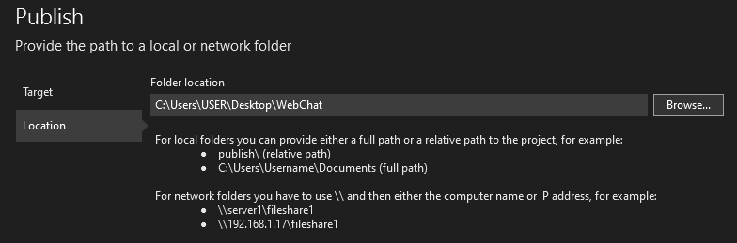

Due to permission issues, we cannot publish the app directly to the IIS folder.

Once done, click on the Publish button to publish the application on the given location.

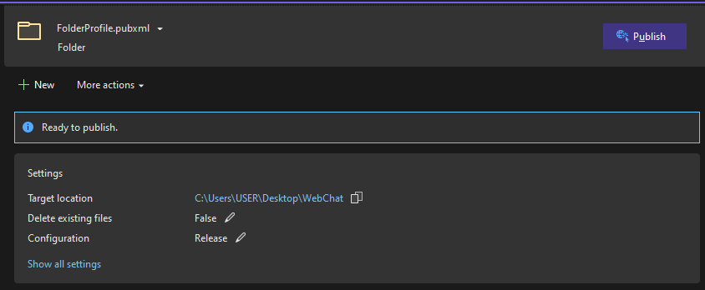

Now copy and paste the published folder inside IIS folder.

Go to **C:\inetpub\wwwroot** and paste the published folder here. Also copy and replace the **iisstart.htm** file given with this documentation in the same directory.

(Mikejo5000, 2022)

**# Step 3. Create a database in SQL Server.**

Open Microsoft SQL Server Management Studio (SSMS) and connect to “.” (period) server using SQL Server Authentication.

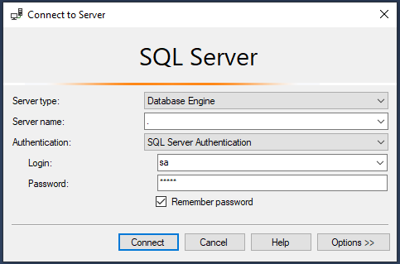

Use the username and password we created when installing SQL Server to login.

Open and execute the SQL query file named “Database-SQL-Query.sql” which is given with this documentation. You can also use the F5 button on your keyboard to run the query.

If the commands were completed successfully, you should see a new Database with the name “WebChat” created under databases folder in Object Explorer.

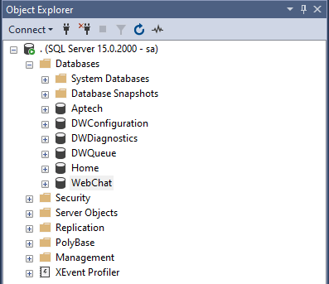

**# Step 4. Configuring IIS settings using IIS Manager.**

Open IIS Manager and expand your **Server** > **Sites** > **Default Web Site** > right-click on **WebChat** and select **Convert to Application**.

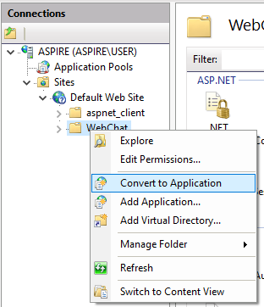

After converting to application. It should look like this.

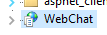

Now click on **Default Web Site** > double-click on **SSL Settings** > choose **Accept**.

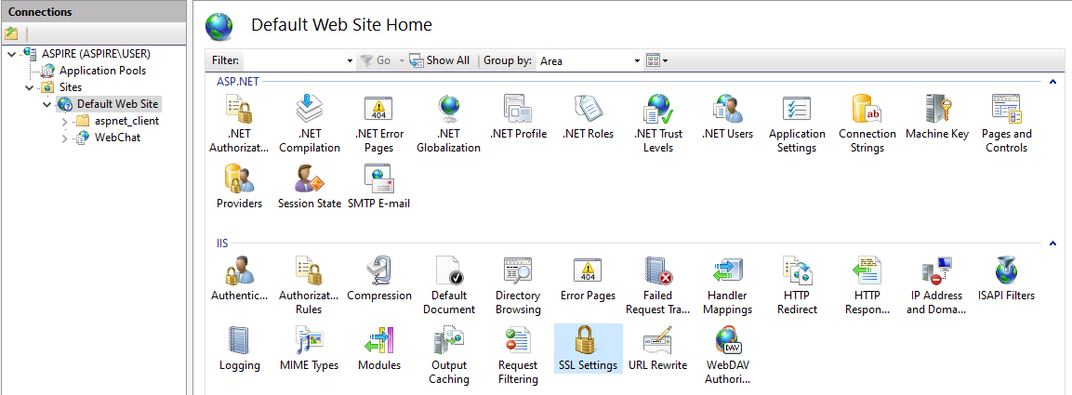

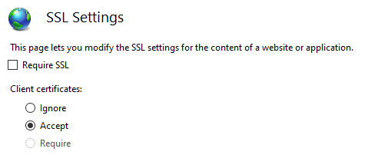

Next right-click on Default Web Site > Edit Bindings > Add.

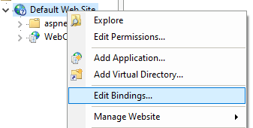

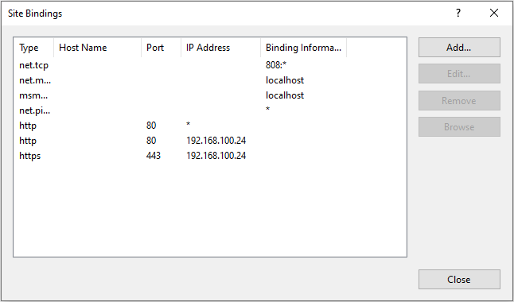

New site binding settings are as following:

|  |  |
| --- | --- |
| **Type** | https |
| **SSL Certificate** | IIS Express Development Certificate |

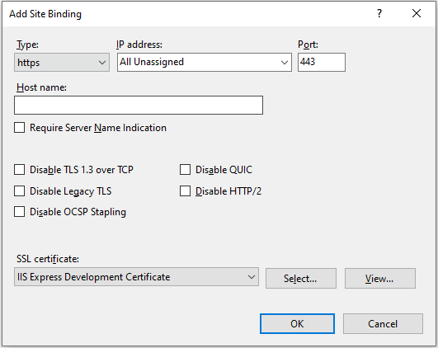

(Dykstra, 2022)

**# Step 5. Configuring Web.config file.**

Go to **C:\inetpub\wwwroot\WebChat** and open **Web.config** with a code editor or notepad and look for **connectionStrings** at line 11.

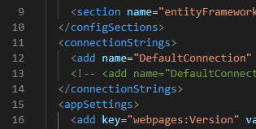

Remove or comment the first connection and uncomment the second connection by removing **<!--** and **-->** from starting and ending of the line.

Your connection string should like this if you followed the steps correctly.



Replace “12345” with your password.



**# Step 6. Configuring windows hosts file for external logins.**

Retrieving your device IPv4 Address. To do this, open Command Prompt (CMD) and type **ipconfig /all** and hit enter.

Scroll down and look for **IPv4 Address** or simply search using CTRL+F.

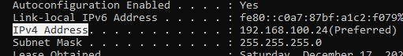

Note down the IP address given here.

Open a browser and go to **localhost** or use the IP address found above or simply browse the app from IIS Manager.

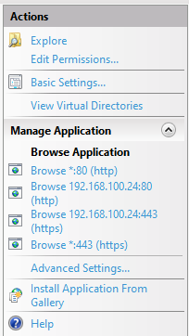

You should see this page.

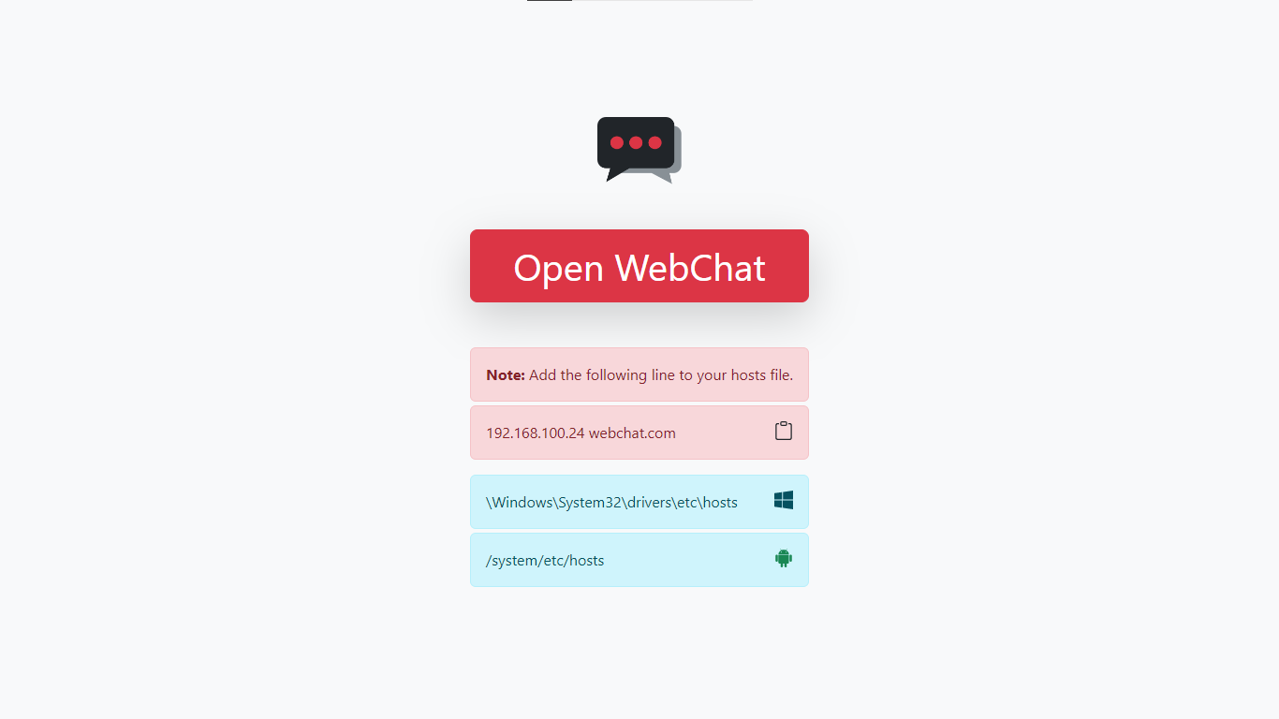

Now open Command Prompt (CMD) with administrator rights and run the following two commands.

**cd \Windows\System32\drivers\etc**

**notepad hosts**

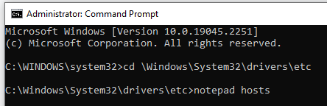

This should open the windows hosts file on a notepad.

Now add “YOUR_IPv4_ADDRESS webchat.com” at the very bottom in a new line without the double quotes.

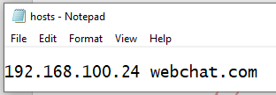

Now you should be able to access the website by using “webchat.com”.

**Note:** You must perform step 6 on all devices you want to access the site using webchat.com. You won’t be able to use external logins like Google when accessing the site using IP address.

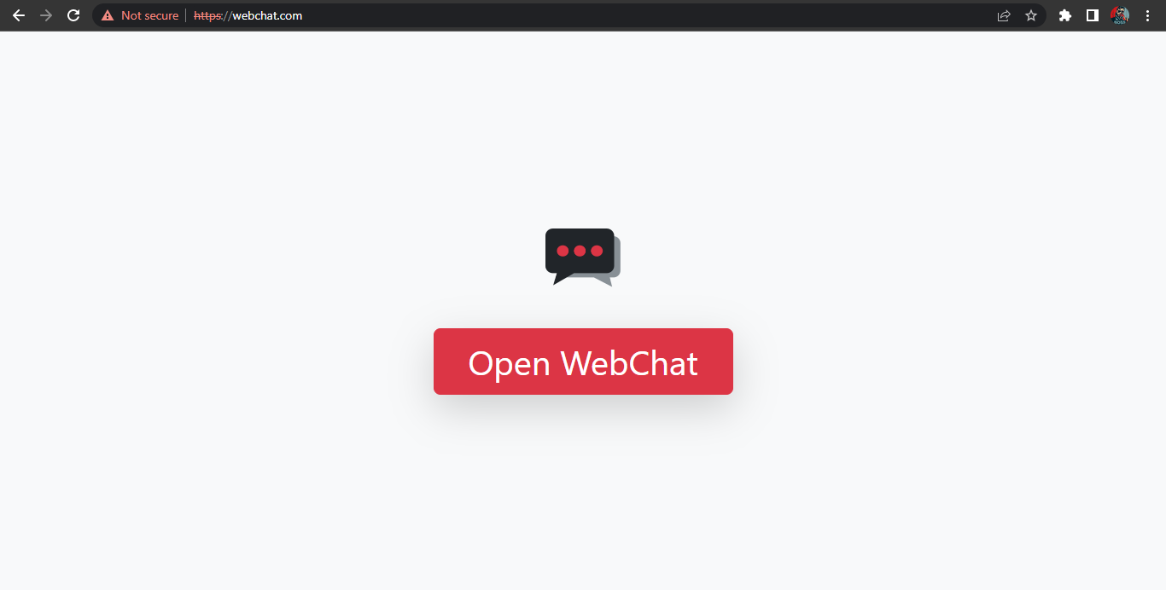

# Conclusion

The main goal of this project was to create secure and private communication system for small groups of people where they can feel relaxed and talk about their daily life without worrying about the outer world.

It was a wonderful and learning experience for me while working on this project. This project took me through the various stages of a business project development and gave me real insight into the world of web app development. The joy of work and the thrill involved while tackling numerous problems and challenges gave me a feel of developer’s industry.

I enjoyed each and every bit of work I had put into this project.

# References

*ASP.NET*. (n.d.). Retrieved from Microsoft: http://asp.net/

Beat, S. (n.d.). *Website Redesign Proposal Template*. Retrieved from Visme: https://www.visme.co/templates/proposals/website-redesign-proposal-1425285156/

*Discord*. (n.d.). Retrieved from Discord: https://discord.com/

Dykstra, T. (2022, June 30). *ASP.NET Web Deployment using Visual Studio: Deploying to Test.* Retrieved from Microsoft: https://learn.microsoft.com/en-us/aspnet/web-forms/overview/deployment/visual-studio-web-deployment/deploying-to-iis

(2023). *Final Report Structure In Computing Project.* NCC Education Limited.

Mikejo5000. (2022, April 29). *Publish an ASP.NET web app.* Retrieved from Microsoft: https://learn.microsoft.com/en-us/visualstudio/deployment/quickstart-deploy-aspnet-web-app

Otto, M. (2022, November 22). *Bootstrap Documentation*. Retrieved from Bootstrap: https://getbootstrap.com/docs/5.2/

Polesny, O. (2021, January 18). *Debounce – How to Delay a Function in JavaScript (JS ES6 Example)*. Retrieved from freeCodeCamp: https://www.freecodecamp.org/news/javascript-debounce-example/

*SQL Server*. (2022). Retrieved from Microsoft: https://www.microsoft.com/sql-server/

*Web Development with ASP.NET MVC and Core.* (2022). Doha: Aptech Limited.

Wick, J. (n.d.). *Web Development Project Proposal Template*. Retrieved from Visme: https://www.visme.co/templates/proposals/web-development-project-proposal-1425280046/